2018 spring WS

Confidences are calculated:

**p = exp( X*beta ) / ( 1 + exp(X*beta) ) ,**

**1-p = 1/ ( 1 + exp(X*beta) )**

* How to calculate M/W for Problem type
* File is ‘delete blank.xlsx.’

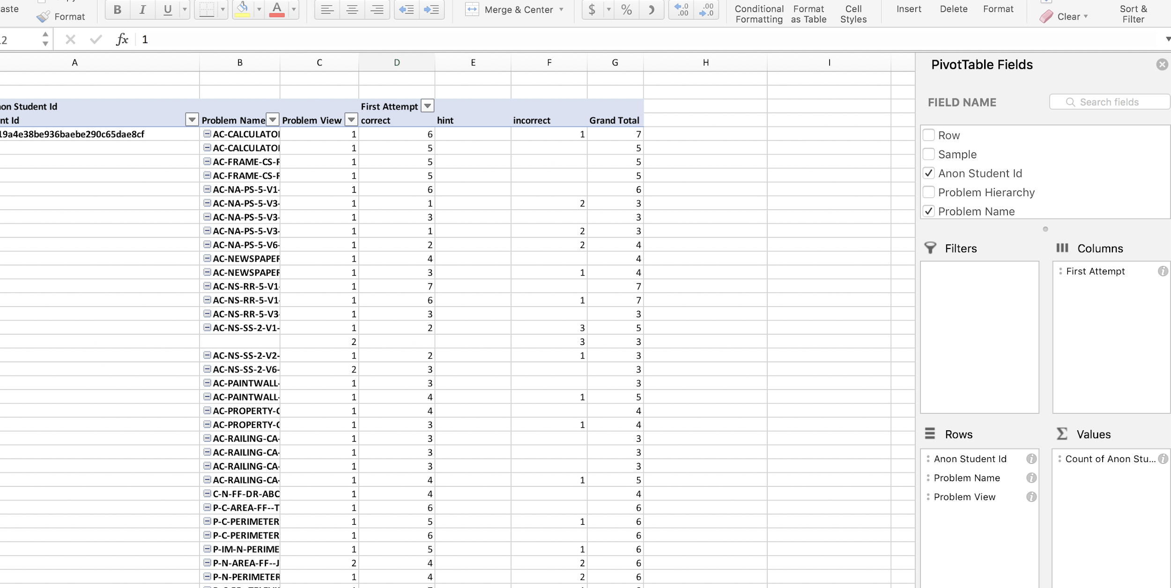

* Make Problem type and ‘PT view’ for each problem type. ( based on PT and Problem Name).

=IF(G1<>G2,1,IF(E1<>E2,H1+1,H1))

|  |  |
| --- | --- |
| **Problem type** | **Max of PT view** |
| circle | 27 |
| parallelogram | 27 |
| rectangle | 34 |
| square | 17 |
| trapezoid | 17 |
| triangle | 14 |
| **Grand Total** | **34** |

K-medoid clustering to get problem type

3/28

Noboru wanted to use SMART to make problem type.

So I asked Abhisek to run Smart to make problem type when k=25,50,75,100.

4/11

We try to use KC models in datashop in deciding which kluster number we gonna use.

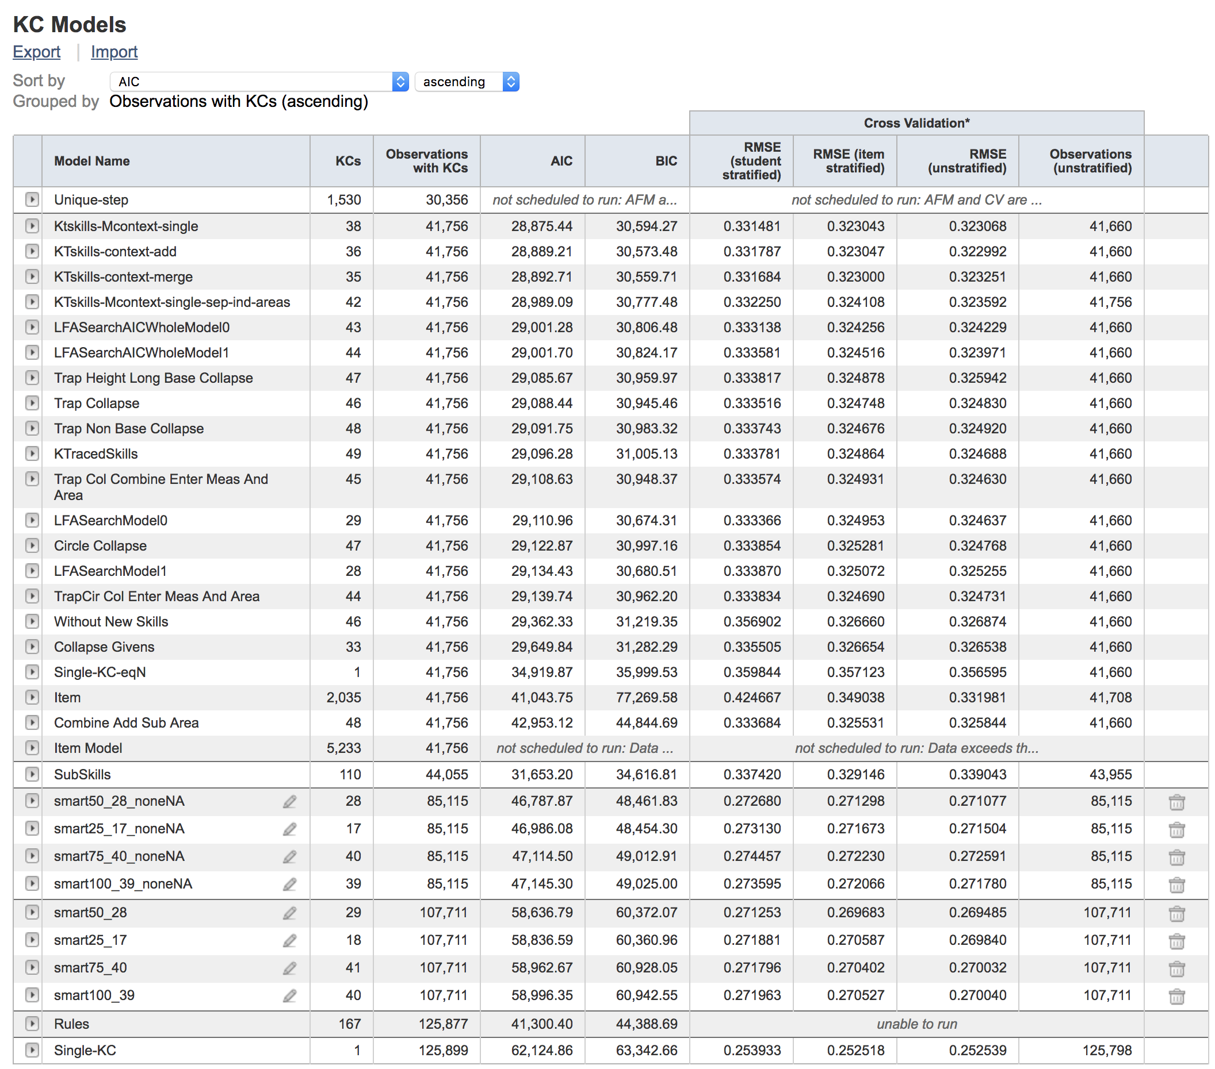

Determine use smart 50_28_noneNA : because it has lowest RMSE. Matsuda said AIC is under the influence of the number of observations.

This is from cognitive tutor!. Because we put ‘hint messages per tutor’ for generating smart skills. Non-relevant to skills.

* idkc_independent

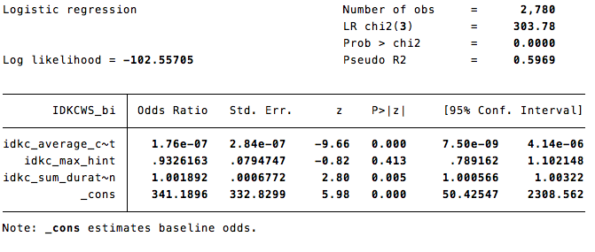

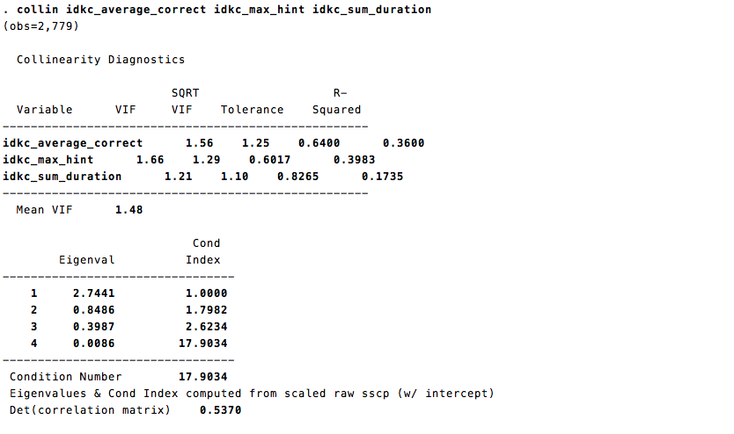

* idpt_independent

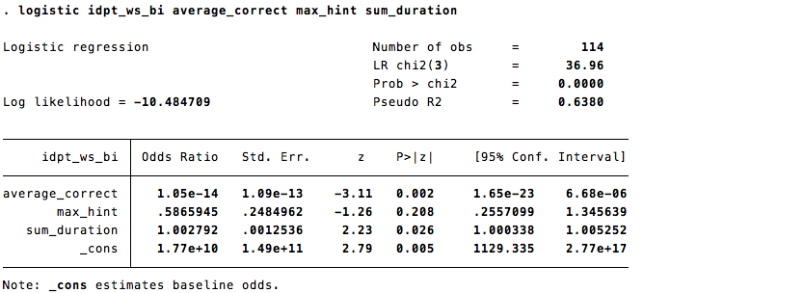

* Idpt_non independent

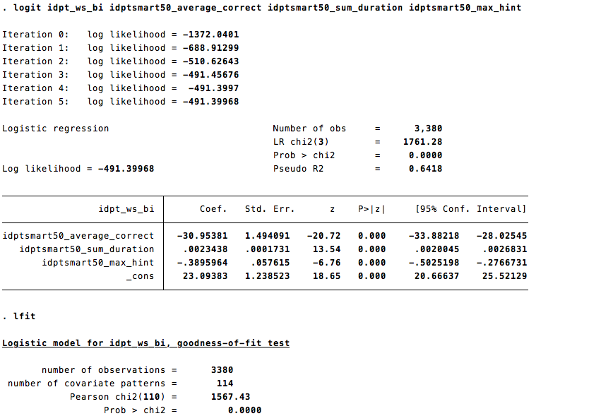

* IDKC_ non indenpent

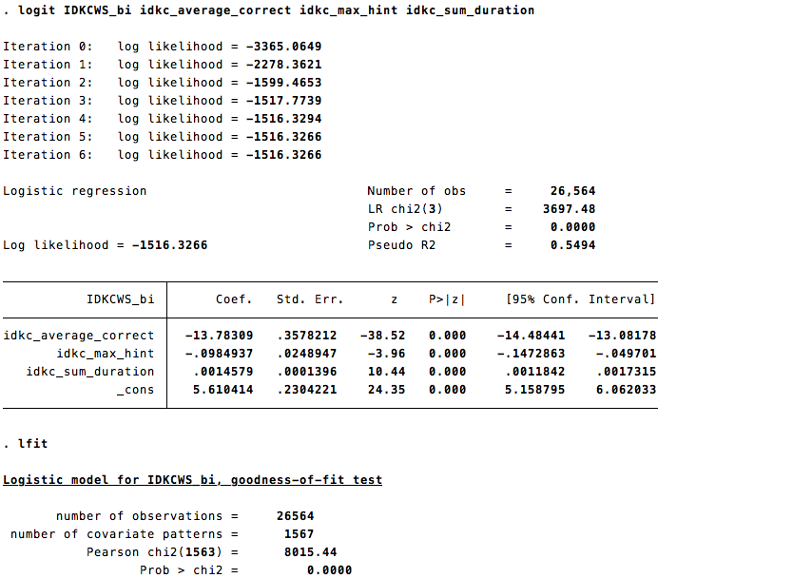

* Non-independent idpt/idkc data has all significant variables.

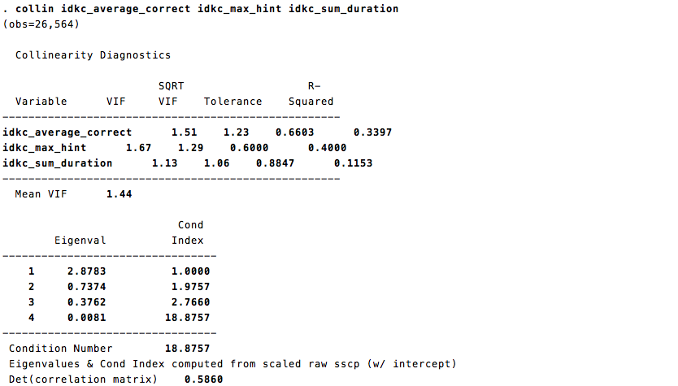

4/15.

When I asked Lucy (TA of Dr. Luo), that if I can run logistic regression, and I should not use the student-step, or other dataset inself. Because this data is not independent. I should clustered each idkc/ idpt/ or whatever level into one row. However, I’m not sure this is just for violation of regression’s assumptions. Or this might be okay for other techniques such as neural net. I don’t know other technique has also same assumptions.

* Neil Heffernan, poster in AERA, they said that they provided teachers students’ performance in the problem unit, not skill unit. Because this help teachers understand each student’s performance better ( intuitively). Heffernan found that the group who don’t have prior knowledge enough showed much more achievement progress. He hypothesized that this is because this information make teachers pay attention to more to those students who don’t have enough prior knowledge.
* Because variables are all significant in non-independent data for both idkc/idpt, I will use those. (idkc_statadataset/ idpt_statadataset ; ‘independent observation’ means that I extract one row per idkc/idpt because all rows in each idkc/idpt has the same value in the data that I created, ‘non-inderterminate’ means that I exclude “I” group from the dependent variable(idkc ws/ idpt ws))

You can regress the response on the covariates only and then re-run the regression using depression ~ IVs + offset(b1 * covariate1 + ... + bn * covariaten) where b1, ..., bn are the coefficients from the first regression.

I found variables about ‘viewpt ~’ is confusing. I deleted the function so I cannot actually know what I did. But when I see how the data sort out - 1)id then pt~, then stpe end time. But I’m not sure. So I made view for IDPT again.

What I will do for Giftsym6 paper.

* Make dataset for both idkc/ idpt ws with idkc/idpt_ave_correct, max_hint, sum_duration ( and id/kc/pt_average correct) per opportunity 3-9.
* How to make this??????? Lol

1. Make view(opp) for idpt/idkc/kc/pt/id : =IF(AX1=AX2,AY1+1,1)
2. Make pivot table using idpt/idkc/kc/pt/id and view(opp).
3. Calculate ave_correct per view(opp) : =IF(ISBLANK(D2),M2,(B2+C2+D2)/$D$1) -opp3

=IF(ISBLANK(E2),N2,(B2+C2+D2+E2)/$E$1) -opp4

=IF(ISBLANK(F2),O2,(B2+C2+D2+E2+F2)/$F$1) - opp5

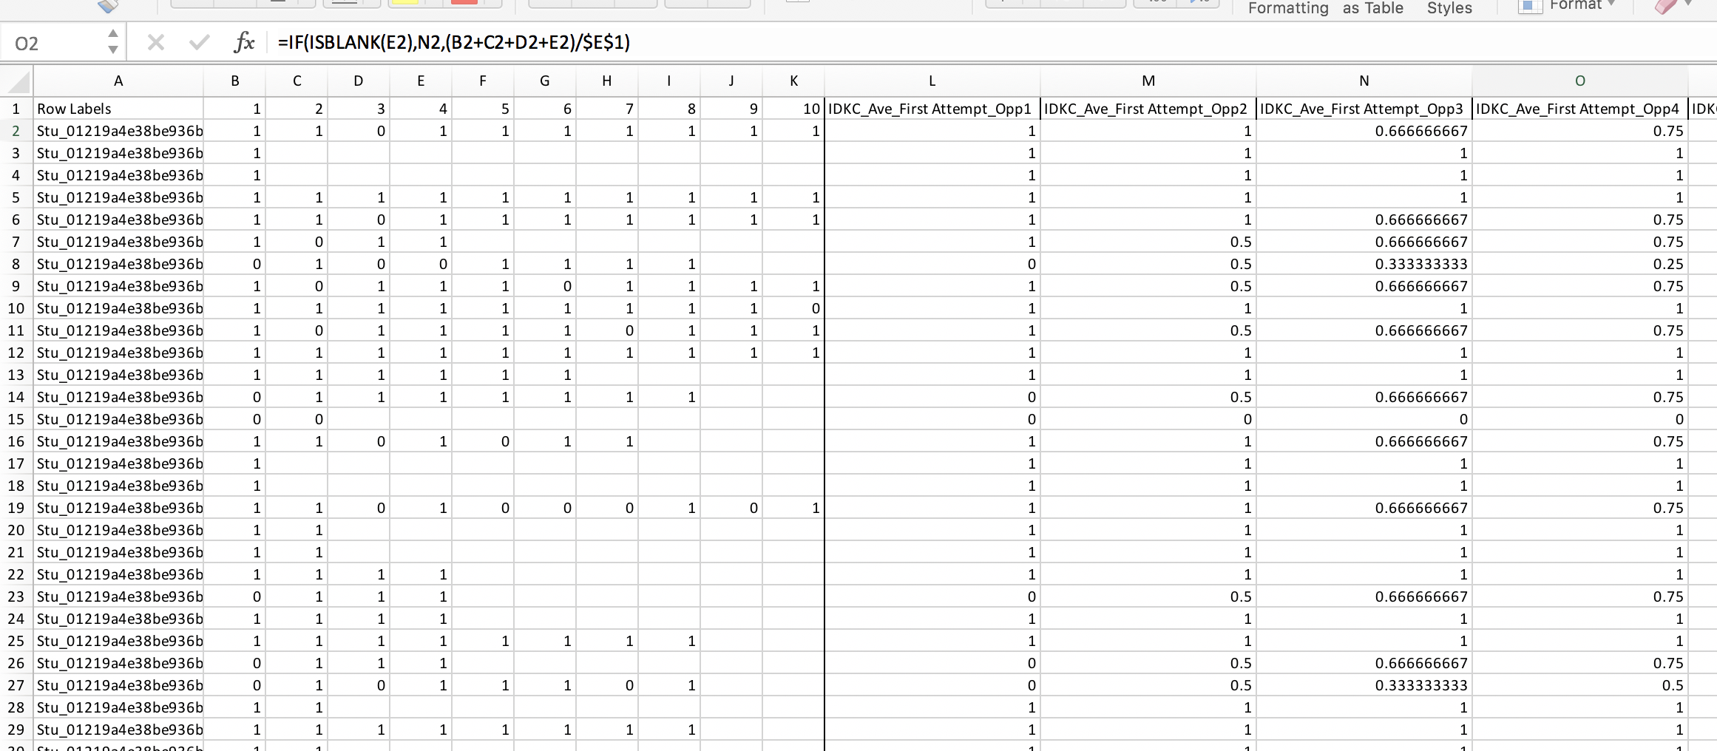

4) make idkc/idpt ws (dependent variable) per opportunity 3-9; =IF(EF3<=1,"M",IF(EH3<3,"I","W")) ~

=IF(EF3<=7,"M",IF(EH3<9,"I","W"))

Final dataset : idkc_dataset & idpt_dataset

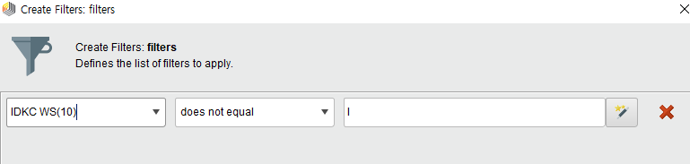

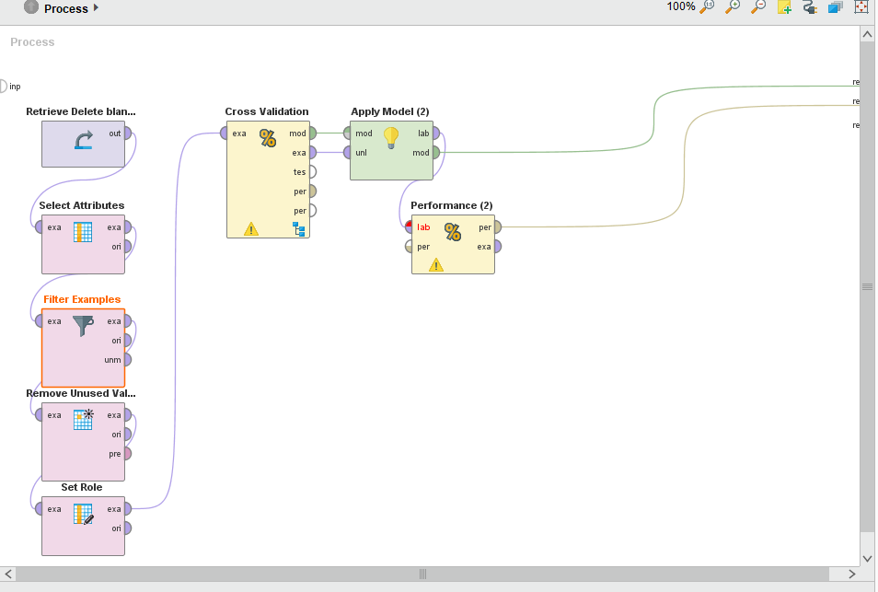

OPP4 IDPT Deep learning

# **DeepLearning**

Model Metrics Type: Binomial  
 Description: Metrics reported on temporary training frame with 10017 samples  
 model id: rm-h2o-model-deep_learning-964268  
 frame id: rm-h2o-frame-deep_learning-978310.temporary.sample.31.45%  
 MSE: 0.08565222  
 R^2: -0.093650654  
 AUC: 0.76862955  
 logloss: 1.0463316  
 CM: Confusion Matrix (vertical: actual; across: predicted):  
 M W Error Rate  
 M 6902 2257 0.2464 = 2,257 / 9,159  
 W 247 611 0.2879 = 247 / 858  
Totals 7149 2868 0.2500 = 2,504 / 10,017  
Gains/Lift Table (Avg response rate: 8.57 %):  
 Group Cumulative Data Fraction Lower Threshold Lift Cumulative Lift Response Rate Cumulative Response Rate Capture Rate Cumulative Capture Rate Gain Cumulative Gain  
 1 0.01587302 0.000056 4.479021 4.479021 0.383648 0.383648 0.071096 0.071096 347.902098 347.902098  
 2 0.02136368 0.000055 4.245391 4.418976 0.363636 0.378505 0.023310 0.094406 324.539097 341.897588  
 3 0.03014875 0.000047 1.326685 3.517911 0.113636 0.301325 0.011655 0.106061 32.668468 251.791090  
 4 0.04063093 0.000039 1.223077 2.925878 0.104762 0.250614 0.012821 0.118881 22.307692 192.587756  
 5 0.05031447 0.000032 2.888617 2.918706 0.247423 0.250000 0.027972 0.146853 188.861654 191.870629  
 6 0.10062893 0.000014 0.996066 1.957386 0.085317 0.167659 0.050117 0.196970 -0.393357 95.738636  
 7 0.15024458 0.000009 2.724909 2.210847 0.233400 0.189369 0.135198 0.332168 172.490889 121.084729  
 8 0.20085854 0.000006 3.154736 2.448696 0.270217 0.209742 0.159674 0.491841 215.473580 144.869594  
 9 0.30008985 0.000004 2.219861 2.373027 0.190141 0.203260 0.220280 0.712121 121.986112 137.302667  
 10 0.40321454 0.000002 0.395565 1.867278 0.033882 0.159941 0.040793 0.752914 -60.443477 86.727830  
 11 0.50044924 0.000001 1.306526 1.758327 0.111910 0.150608 0.127040 0.879953 30.652561 75.832695  
 12 0.60007986 0.000000 0.772083 1.594582 0.066132 0.136583 0.076923 0.956876 -22.791737 59.458184  
 13 0.70140761 0.000000 0.253050 1.400780 0.021675 0.119983 0.025641 0.982517 -74.694960 40.077962  
 14 0.80063891 0.000000 0.000000 1.227167 0.000000 0.105112 0.000000 0.982517 -100.000000 22.716679  
 15 0.90595987 0.000000 0.000000 1.084504 0.000000 0.092893 0.000000 0.982517 -100.000000 8.450442  
 16 1.00000000 0.000000 0.185905 1.000000 0.015924 0.085654 0.017483 1.000000 -81.409514 0.000000  
Status of Neuron Layers (predicting idpt_ws_opp10, 2-class classification, bernoulli distribution, CrossEntropy loss, 2,902 weights/biases, 38.8 KB, 318,010 training samples, mini-batch size 1):  
 Layer Units Type Dropout L1 L2 Mean Rate Rate RMS Momentum Mean Weight Weight RMS Mean Bias Bias RMS  
 1 4 Input 0.00 %   
 2 50 Rectifier 0.00 % 0.000010 0.000000 0.867346 0.301179 0.000000 -0.019705 0.288824 0.513130 0.343997  
 3 50 Rectifier 0.00 % 0.000010 0.000000 0.660445 0.427877 0.000000 -0.009891 0.124066 0.810508 0.153366  
 4 2 Softmax 0.000010 0.000000 0.757819 0.391250 0.000000 -0.004963 0.437953 0.000000 0.000007  
Scoring History:  
 Timestamp Duration Training Speed Epochs Iterations Samples Training MSE Training R^2 Training LogLoss Training AUC Training Lift Training Classification Error  
 2018-04-18 10:54:27 0.000 sec 0.00000 0 0.000000 NaN NaN NaN NaN NaN NaN  
 2018-04-18 10:54:28 2.002 sec 18172 rows/sec 1.00000 1 31801.000000 0.08565 -0.09365 1.05056 0.79427 0.54050 0.23390  
 2018-04-18 10:54:35 8.202 sec 20196 rows/sec 5.00000 5 159005.000000 0.08565 -0.09365 1.06477 0.77701 1.03013 0.21923  
 2018-04-18 10:54:40 13.931 sec 21145 rows/sec 9.00000 9 286209.000000 0.08565 -0.09365 1.07468 0.76809 1.01032 0.19756  
 2018-04-18 10:54:42 15.351 sec 21364 rows/sec 10.00000 10 318010.000000 0.08565 -0.09365 1.04633 0.76863 4.47902 0.24998  
  
H2O version: 3.8.2.6-rm7.6.1

**Neural net opp4**

# **ImprovedNeuralNet**

Hidden 1  
========  
  
Node 1 (Sigmoid)  
----------------  
idpt_ave_correct_opp4: 35.715  
idpt_maxhint_opp4: 69.133  
idpt_sumduration_opp4: -28.368  
pt_ave_correct_opp4: 15.895  
Bias: 17.548  
  
Node 2 (Sigmoid)  
----------------  
idpt_ave_correct_opp4: 26.917  
idpt_maxhint_opp4: -54.721  
idpt_sumduration_opp4: 30.655  
pt_ave_correct_opp4: -15.908  
Bias: -13.295  
  
Node 3 (Sigmoid)  
----------------  
idpt_ave_correct_opp4: 19.448  
idpt_maxhint_opp4: -18.144  
idpt_sumduration_opp4: 17.910  
pt_ave_correct_opp4: -15.527  
Bias: -5.534  
  
Node 4 (Sigmoid)  
----------------  
idpt_ave_correct_opp4: 26.862  
idpt_maxhint_opp4: 32.194  
idpt_sumduration_opp4: 12.043  
pt_ave_correct_opp4: 5.414  
Bias: 7.562  
  
  
Output  
======  
  
Class 'M' (Sigmoid)  
-------------------  
Node 1: 1.428  
Node 2: 1.523  
Node 3: 8.200  
Node 4: 8.977  
Threshold: -0.087  
  
Class 'W' (Sigmoid)  
-------------------  
Node 1: -1.428  
Node 2: -1.523  
Node 3: -8.200  
Node 4: -8.977  
Threshold: 0.087

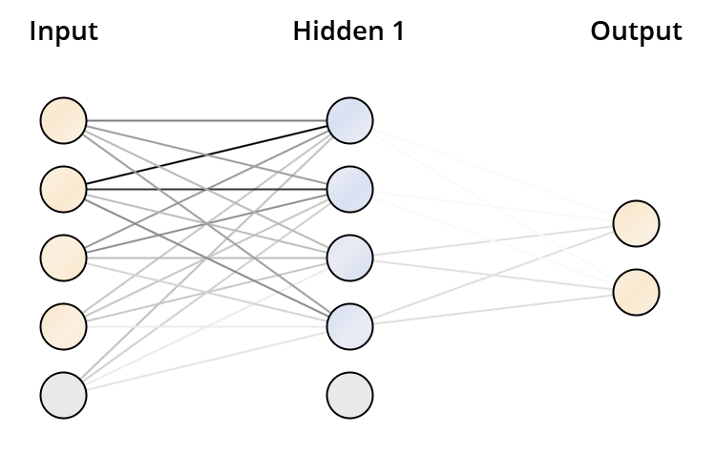

OPP5

# **DeepLearning**

Model Metrics Type: Binomial  
 Description: Metrics reported on temporary training frame with 10031 samples  
 model id: rm-h2o-model-deep_learning-997069  
 frame id: rm-h2o-frame-deep_learning-864469.temporary.sample.31.45%  
 MSE: 0.08672417  
 R^2: -0.09487989  
 AUC: 0.8355851  
 logloss: 1.0098964  
 CM: Confusion Matrix (vertical: actual; across: predicted):  
 M W Error Rate  
 M 7726 1435 0.1566 = 1,435 / 9,161  
 W 236 634 0.2713 = 236 / 870  
Totals 7962 2069 0.1666 = 1,671 / 10,031  
Gains/Lift Table (Avg response rate: 8.67 %):  
 Group Cumulative Data Fraction Lower Threshold Lift Cumulative Lift Response Rate Cumulative Response Rate Capture Rate Cumulative Capture Rate Gain Cumulative Gain  
 1 0.01006879 0.000210 5.936178 5.936178 0.514851 0.514851 0.059770 0.059770 493.617845 493.617845  
 2 0.02013757 0.000073 8.219324 7.077751 0.712871 0.613861 0.082759 0.142529 721.932400 607.775122  
 3 0.03160203 0.000049 2.907536 5.564897 0.252174 0.482650 0.033333 0.175862 190.753623 456.489720  
 4 0.04017546 0.000044 4.156121 5.264265 0.360465 0.456576 0.035632 0.211494 315.612136 426.426514  
 5 0.05034393 0.000038 3.165066 4.840269 0.274510 0.419802 0.032184 0.243678 216.506649 384.026858  
 6 0.10008972 0.000017 2.911354 3.881575 0.252505 0.336653 0.144828 0.388506 191.135374 288.157485  
 7 0.15083242 0.000012 3.397805 3.718826 0.294695 0.322538 0.172414 0.560920 239.780503 271.882611  
 8 0.20077759 0.000004 2.508498 3.417746 0.217565 0.296425 0.125287 0.686207 150.849795 241.774646  
 9 0.30026917 0.000002 1.132193 2.660448 0.098196 0.230744 0.112644 0.798851 13.219312 166.044825  
 10 0.40095703 0.000001 0.582202 2.138561 0.050495 0.185480 0.058621 0.857471 -41.779788 113.856148  
 11 0.50154521 0.000001 0.537071 1.817372 0.046581 0.157623 0.054023 0.911494 -46.292904 81.737206  
 12 0.60213339 0.000000 0.434228 1.586314 0.037661 0.137583 0.043678 0.955172 -56.577242 58.631366  
 13 0.70242249 0.000000 0.000000 1.359826 0.000000 0.117939 0.000000 0.955172 -100.000000 35.982607  
 14 0.80191407 0.000000 0.127083 1.206883 0.011022 0.104674 0.012644 0.967816 -87.291710 20.688255  
 15 0.90010966 0.000000 0.035116 1.079051 0.003046 0.093587 0.003448 0.971264 -96.488360 7.905115  
 16 1.00000000 0.000000 0.287672 1.000000 0.024950 0.086731 0.028736 1.000000 -71.232822 0.000000  
Status of Neuron Layers (predicting idpt_ws_opp10, 2-class classification, bernoulli distribution, CrossEntropy loss, 2,902 weights/biases, 38.8 KB, 318,010 training samples, mini-batch size 1):  
 Layer Units Type Dropout L1 L2 Mean Rate Rate RMS Momentum Mean Weight Weight RMS Mean Bias Bias RMS  
 1 4 Input 0.00 %   
 2 50 Rectifier 0.00 % 0.000010 0.000000 0.968893 0.140027 0.000000 -0.002823 0.197935 0.515094 0.047861  
 3 50 Rectifier 0.00 % 0.000010 0.000000 0.840875 0.354372 0.000000 -0.001970 0.123235 0.972691 0.040413  
 4 2 Softmax 0.000010 0.000000 0.871663 0.321898 0.000000 0.004754 0.436694 0.000001 0.000000  
Scoring History:  
 Timestamp Duration Training Speed Epochs Iterations Samples Training MSE Training R^2 Training LogLoss Training AUC Training Lift Training Classification Error  
 2018-04-18 11:08:11 0.000 sec 0.00000 0 0.000000 NaN NaN NaN NaN NaN NaN  
 2018-04-18 11:08:13 1.766 sec 18861 rows/sec 1.00000 1 31801.000000 0.08672 -0.09488 1.00990 0.83559 5.93618 0.16658  
 2018-04-18 11:08:20 8.282 sec 19540 rows/sec 5.00000 5 159005.000000 0.08672 -0.09487 1.05513 0.82574 8.33348 0.15691  
 2018-04-18 11:08:26 14.737 sec 19699 rows/sec 9.00000 9 286209.000000 0.08673 -0.09493 1.13829 0.76320 7.83162 0.13578  
 2018-04-18 11:08:28 16.356 sec 19771 rows/sec 10.00000 10 318010.000000 0.08673 -0.09494 1.13373 0.78089 7.83162 0.09899  
 2018-04-18 11:08:28 16.422 sec 19769 rows/sec 10.00000 10 318010.000000 0.08672 -0.09488 1.00990 0.83559 5.93618 0.16658  
  
H2O version: 3.8.2.6-rm7.6.1

NNOPP5

# **ImprovedNeuralNet**

Hidden 1  
========  
  
Node 1 (Sigmoid)  
----------------  
idpt_ave_correct_opp5: 20.542  
idpt_maxhint_opp5: 2.822  
idpt_sumduration_opp5: -7.853  
pt_ave_correct_opp5: -5.790  
Bias: 7.313  
  
Node 2 (Sigmoid)  
----------------  
idpt_ave_correct_opp5: 42.930  
idpt_maxhint_opp5: -25.281  
idpt_sumduration_opp5: 40.409  
pt_ave_correct_opp5: -15.952  
Bias: 7.067  
  
Node 3 (Sigmoid)  
----------------  
idpt_ave_correct_opp5: 24.054  
idpt_maxhint_opp5: 33.449  
idpt_sumduration_opp5: -1.540  
pt_ave_correct_opp5: -1.634  
Bias: 4.433  
  
Node 4 (Sigmoid)  
----------------  
idpt_ave_correct_opp5: 15.102  
idpt_maxhint_opp5: -2.527  
idpt_sumduration_opp5: 6.745  
pt_ave_correct_opp5: -2.339  
Bias: -8.869  
  
  
Output  
======  
  
Class 'M' (Sigmoid)  
-------------------  
Node 1: 1.882  
Node 2: 2.603  
Node 3: 10.209  
Node 4: 4.015  
Threshold: -0.926  
  
Class 'W' (Sigmoid)  
-------------------  
Node 1: -1.882  
Node 2: -2.603  
Node 3: -10.209  
Node 4: -4.015  
Threshold: 0.926

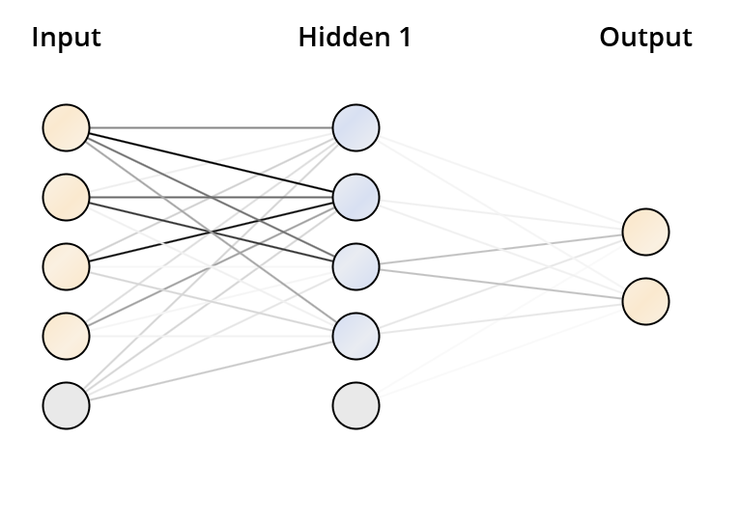

IDPT OPP6

# **DeepLearning**

Model Metrics Type: Binomial  
 Description: Metrics reported on temporary training frame with 9842 samples  
 model id: rm-h2o-model-deep_learning-37581  
 frame id: rm-h2o-frame-deep_learning-23594.temporary.sample.31.45%  
 MSE: 0.08425122  
 R^2: -0.09104748  
 AUC: 0.86623794  
 logloss: 0.88200676  
 CM: Confusion Matrix (vertical: actual; across: predicted):  
 M W Error Rate  
 M 8055 957 0.1062 = 957 / 9,012  
 W 377 453 0.4542 = 377 / 830  
Totals 8432 1410 0.1355 = 1,334 / 9,842  
Gains/Lift Table (Avg response rate: 8.43 %):  
 Group Cumulative Data Fraction Lower Threshold Lift Cumulative Lift Response Rate Cumulative Response Rate Capture Rate Cumulative Capture Rate Gain Cumulative Gain  
 1 0.01046535 0.003101 5.410855 5.410855 0.456311 0.456311 0.056627 0.056627 441.085507 441.085507  
 2 0.02184515 0.002576 5.081928 5.239507 0.428571 0.441860 0.057831 0.114458 408.192771 423.950686  
 3 0.03078643 0.000734 7.141648 5.791944 0.602273 0.488449 0.063855 0.178313 614.164841 479.194401  
 4 0.04023572 0.000401 4.590128 5.509699 0.387097 0.464646 0.043373 0.221687 359.012825 450.969940  
 5 0.05029466 0.000215 5.030595 5.413879 0.424242 0.456566 0.050602 0.272289 403.059511 441.387854  
 6 0.10130055 0.000038 2.102285 3.746456 0.177291 0.315948 0.107229 0.379518 110.228484 274.645624  
 7 0.15098557 0.000018 3.346382 3.614803 0.282209 0.304845 0.166265 0.545783 234.638185 261.480322  
 8 0.20006096 0.000007 2.553239 3.354399 0.215321 0.282885 0.125301 0.671084 155.323904 235.439921  
 9 0.30014225 0.000002 1.962260 2.890196 0.165482 0.243737 0.196386 0.867470 96.226041 189.019585  
 10 0.40002032 0.000000 0.687585 2.340243 0.057986 0.197358 0.068675 0.936145 -31.241466 134.024256  
 11 0.50000000 0.000000 0.325367 1.937349 0.027439 0.163381 0.032530 0.968675 -67.463268 93.734940  
 12 0.59997968 0.000000 0.156658 1.640618 0.013211 0.138357 0.015663 0.984337 -84.334166 64.061781  
 13 0.70016257 0.000000 0.156341 1.428240 0.013185 0.120447 0.015663 1.000000 -84.365942 42.823973  
 14 0.80075188 0.000000 0.000000 1.248826 0.000000 0.105317 0.000000 1.000000 -100.000000 24.882629  
 15 0.89991872 0.000000 0.000000 1.111211 0.000000 0.093711 0.000000 1.000000 -100.000000 11.121147  
 16 1.00000000 0.000000 0.000000 1.000000 0.000000 0.084332 0.000000 1.000000 -100.000000 0.000000  
Status of Neuron Layers (predicting idpt_ws_opp10, 2-class classification, bernoulli distribution, CrossEntropy loss, 2,902 weights/biases, 38.8 KB, 318,010 training samples, mini-batch size 1):  
 Layer Units Type Dropout L1 L2 Mean Rate Rate RMS Momentum Mean Weight Weight RMS Mean Bias Bias RMS  
 1 4 Input 0.00 %   
 2 50 Rectifier 0.00 % 0.000010 0.000000 0.953752 0.171843 0.000000 -0.026924 0.166249 0.445589 0.078623  
 3 50 Rectifier 0.00 % 0.000010 0.000000 0.927816 0.223572 0.000000 -0.001704 0.107498 0.829491 0.127873  
 4 2 Softmax 0.000010 0.000000 0.962750 0.147831 0.000000 -0.010549 0.436908 -0.000002 0.002378  
Scoring History:  
 Timestamp Duration Training Speed Epochs Iterations Samples Training MSE Training R^2 Training LogLoss Training AUC Training Lift Training Classification Error  
 2018-04-18 11:19:11 0.000 sec 0.00000 0 0.000000 NaN NaN NaN NaN NaN NaN  
 2018-04-18 11:19:12 1.770 sec 18817 rows/sec 1.00000 1 31801.000000 0.08429 -0.09160 0.95290 0.87697 3.59328 0.17750  
 2018-04-18 11:19:18 6.954 sec 18673 rows/sec 4.00000 4 127204.000000 0.08429 -0.09151 0.91667 0.88118 6.85361 0.17547  
 2018-04-18 11:19:23 12.087 sec 18734 rows/sec 7.00000 7 222607.000000 0.08425 -0.09105 0.88201 0.86624 5.41086 0.13554  
 2018-04-18 11:19:28 17.188 sec 18794 rows/sec 10.00000 10 318010.000000 0.08422 -0.09062 0.89889 0.84734 5.52598 0.18035  
 2018-04-18 11:19:28 17.254 sec 18793 rows/sec 10.00000 10 318010.000000 0.08425 -0.09105 0.88201 0.86624 5.41086 0.13554  
  
H2O version: 3.8.2.6-rm7.6.1

OPP6

# **ImprovedNeuralNet**

Hidden 1  
========  
  
Node 1 (Sigmoid)  
----------------  
idpt_ave_correct_opp6: 38.459  
idpt_maxhint_opp6: -14.036  
idpt_sumduration_opp6: -17.479  
pt_ave_correct_opp6: 3.063  
Bias: 4.441  
  
Node 2 (Sigmoid)  
----------------  
idpt_ave_correct_opp6: 41.406  
idpt_maxhint_opp6: -30.015  
idpt_sumduration_opp6: 32.836  
pt_ave_correct_opp6: 1.498  
Bias: -7.012  
  
Node 3 (Sigmoid)  
----------------  
idpt_ave_correct_opp6: 14.404  
idpt_maxhint_opp6: 9.372  
idpt_sumduration_opp6: 22.894  
pt_ave_correct_opp6: -11.261  
Bias: 10.296  
  
Node 4 (Sigmoid)  
----------------  
idpt_ave_correct_opp6: 45.717  
idpt_maxhint_opp6: 26.729  
idpt_sumduration_opp6: 5.177  
pt_ave_correct_opp6: 2.564  
Bias: -0.532  
  
  
Output  
======  
  
Class 'M' (Sigmoid)  
-------------------  
Node 1: 9.379  
Node 2: 1.770  
Node 3: 10.661  
Node 4: 12.859  
Threshold: -9.257  
  
Class 'W' (Sigmoid)  
-------------------  
Node 1: -9.379  
Node 2: -1.770  
Node 3: -10.661  
Node 4: -12.859  
Threshold: 9.257

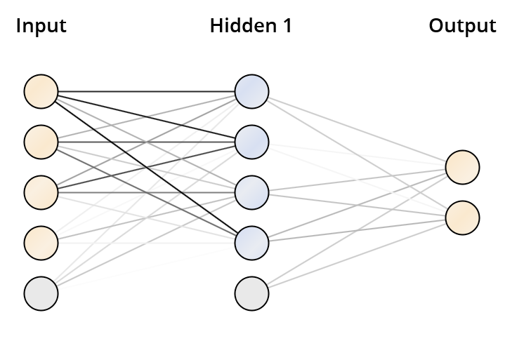

OPP7

# **DeepLearning**

Model Metrics Type: Binomial  
 Description: Metrics reported on temporary training frame with 10016 samples  
 model id: rm-h2o-model-deep_learning-934508  
 frame id: rm-h2o-frame-deep_learning-106923.temporary.sample.31.45%  
 MSE: 0.08457679  
 R^2: -0.075280234  
 AUC: 0.91593593  
 logloss: 0.6112126  
 CM: Confusion Matrix (vertical: actual; across: predicted):  
 M W Error Rate  
 M 8242 912 0.0996 = 912 / 9,154  
 W 233 629 0.2703 = 233 / 862  
Totals 8475 1541 0.1143 = 1,145 / 10,016  
Gains/Lift Table (Avg response rate: 8.61 %):  
 Group Cumulative Data Fraction Lower Threshold Lift Cumulative Lift Response Rate Cumulative Response Rate Capture Rate Cumulative Capture Rate Gain Cumulative Gain  
 1 0.01048323 0.032065 9.406253 9.406253 0.809524 0.809524 0.098608 0.098608 840.625345 840.625345  
 2 0.02006789 0.008277 8.230472 8.844686 0.708333 0.761194 0.078886 0.177494 723.047177 784.468608  
 3 0.03025160 0.006602 6.834994 8.168156 0.588235 0.702970 0.069606 0.247100 583.499386 716.815603  
 4 0.04063498 0.005026 1.564162 6.480649 0.134615 0.557740 0.016241 0.263341 56.416206 548.064897  
 5 0.05121805 0.003415 4.713567 6.115521 0.405660 0.526316 0.049884 0.313225 371.356652 511.552082  
 6 0.10113818 0.000556 3.718237 4.932261 0.320000 0.424482 0.185615 0.498840 271.823666 393.226112  
 7 0.15265575 0.000218 4.210939 4.688833 0.362403 0.403532 0.216937 0.715777 321.093905 368.883261  
 8 0.20047923 0.000091 1.552500 3.940674 0.133612 0.339143 0.074246 0.790023 55.249965 294.067350  
 9 0.30051917 0.000043 1.577096 3.153861 0.135729 0.271429 0.157773 0.947796 57.709639 215.386145  
 10 0.40095847 0.000002 0.519758 2.494024 0.044732 0.214641 0.052204 1.000000 -48.024152 149.402390  
 11 0.50019968 0.000000 0.000000 1.999202 0.000000 0.172056 0.000000 1.000000 -100.000000 99.920160  
 12 0.60143770 0.000000 0.000000 1.662683 0.000000 0.143094 0.000000 1.000000 -100.000000 66.268260  
 13 0.70017971 0.000000 0.000000 1.428205 0.000000 0.122915 0.000000 1.000000 -100.000000 42.820476  
 14 0.80211661 0.000000 0.000000 1.246702 0.000000 0.107294 0.000000 1.000000 -100.000000 24.670152  
 15 0.90225639 0.000000 0.000000 1.108332 0.000000 0.095386 0.000000 1.000000 -100.000000 10.833241  
 16 1.00000000 0.000000 0.000000 1.000000 0.000000 0.086062 0.000000 1.000000 -100.000000 0.000000  
Status of Neuron Layers (predicting idpt_ws_opp10, 2-class classification, bernoulli distribution, CrossEntropy loss, 2,902 weights/biases, 38.8 KB, 318,010 training samples, mini-batch size 1):  
 Layer Units Type Dropout L1 L2 Mean Rate Rate RMS Momentum Mean Weight Weight RMS Mean Bias Bias RMS  
 1 4 Input 0.00 %   
 2 50 Rectifier 0.00 % 0.000010 0.000000 0.922330 0.200456 0.000000 -0.022202 0.202239 0.421638 0.139035  
 3 50 Rectifier 0.00 % 0.000010 0.000000 0.904582 0.243703 0.000000 0.000197 0.094476 0.704324 0.109200  
 4 2 Softmax 0.000010 0.000000 0.979240 0.131858 0.000000 -0.005485 0.437540 -0.000001 0.000193  
Scoring History:  
 Timestamp Duration Training Speed Epochs Iterations Samples Training MSE Training R^2 Training LogLoss Training AUC Training Lift Training Classification Error  
 2018-04-18 11:30:50 0.000 sec 0.00000 0 0.000000 NaN NaN NaN NaN NaN NaN  
 2018-04-18 11:30:52 1.842 sec 18038 rows/sec 1.00000 1 31801.000000 0.08602 -0.09363 0.79363 0.92650 6.91159 0.10543  
 2018-04-18 11:30:58 7.384 sec 17574 rows/sec 4.00000 4 127204.000000 0.08593 -0.09252 0.76432 0.90323 5.97263 0.12959  
 2018-04-18 11:31:03 12.918 sec 17521 rows/sec 7.00000 7 222607.000000 0.08518 -0.08298 0.73056 0.90043 9.21546 0.10823  
 2018-04-18 11:31:09 18.390 sec 17556 rows/sec 10.00000 10 318010.000000 0.08458 -0.07528 0.61121 0.91594 9.40625 0.11432  
  
H2O version: 3.8.2.6-rm7.6.1

IDPT OPP7

# **ImprovedNeuralNet**

Hidden 1  
========  
  
Node 1 (Sigmoid)  
----------------  
idpt_ave_correct_opp7: 17.549  
idpt_maxhint_opp7: -14.796  
idpt_sumduration_opp7: -37.806  
pt_ave_correct_opp7: -27.786  
Bias: -24.192  
  
Node 2 (Sigmoid)  
----------------  
idpt_ave_correct_opp7: 65.758  
idpt_maxhint_opp7: -28.657  
idpt_sumduration_opp7: 49.567  
pt_ave_correct_opp7: 14.781  
Bias: -0.454  
  
Node 3 (Sigmoid)  
----------------  
idpt_ave_correct_opp7: 41.912  
idpt_maxhint_opp7: -30.907  
idpt_sumduration_opp7: 33.771  
pt_ave_correct_opp7: 2.750  
Bias: -16.906  
  
Node 4 (Sigmoid)  
----------------  
idpt_ave_correct_opp7: 42.430  
idpt_maxhint_opp7: 27.047  
idpt_sumduration_opp7: -7.543  
pt_ave_correct_opp7: -3.294  
Bias: -5.976  
  
  
Output  
======  
  
Class 'M' (Sigmoid)  
-------------------  
Node 1: 2.350  
Node 2: 1.648  
Node 3: 1.664  
Node 4: 12.717  
Threshold: -1.074  
  
Class 'W' (Sigmoid)  
-------------------  
Node 1: -2.350  
Node 2: -1.648  
Node 3: -1.664  
Node 4: -12.717  
Threshold: 1.074

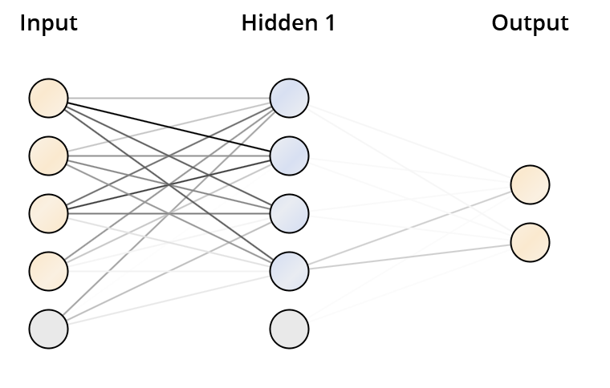

OPP8

# **DeepLearning**

Model Metrics Type: Binomial  
 Description: Metrics reported on temporary training frame with 10071 samples  
 model id: rm-h2o-model-deep_learning-868137  
 frame id: rm-h2o-frame-deep_learning-195206.temporary.sample.31.45%  
 MSE: 0.088218674  
 R^2: -0.08731291  
 AUC: 0.9001705  
 logloss: 0.78647137  
 CM: Confusion Matrix (vertical: actual; across: predicted):  
 M W Error Rate  
 M 8764 410 0.0447 = 410 / 9,174  
 W 422 475 0.4705 = 422 / 897  
Totals 9186 885 0.0826 = 832 / 10,071  
Gains/Lift Table (Avg response rate: 8.91 %):  
 Group Cumulative Data Fraction Lower Threshold Lift Cumulative Lift Response Rate Cumulative Response Rate Capture Rate Cumulative Capture Rate Gain Cumulative Gain  
 1 0.01171681 0.002829 9.324471 9.324471 0.830508 0.830508 0.109253 0.109253 832.447140 832.447140  
 2 0.02055407 0.001472 8.830559 9.112113 0.786517 0.811594 0.078038 0.187291 783.055879 811.211284  
 3 0.03018568 0.001161 9.606972 9.270012 0.855670 0.825658 0.092531 0.279822 860.697169 827.001188  
 4 0.04021448 0.000760 7.559058 8.843330 0.673267 0.787654 0.075808 0.355630 655.905825 784.332962  
 5 0.05044186 0.000531 3.379128 7.735430 0.300971 0.688976 0.034560 0.390190 237.912784 673.543044  
 6 0.10018866 0.000123 2.958124 5.363349 0.263473 0.477701 0.147157 0.537347 195.812389 436.334859  
 7 0.15082911 0.000041 2.619732 4.442187 0.233333 0.395655 0.132664 0.670011 161.973244 344.218715  
 8 0.20017873 0.000017 1.378014 3.686783 0.122736 0.328373 0.068004 0.738016 37.801390 268.678333  
 9 0.30016880 0.000009 1.393672 2.922919 0.124131 0.260337 0.139353 0.877369 39.367239 192.291872  
 10 0.40005958 0.000002 0.948639 2.429961 0.084493 0.216431 0.094760 0.972129 -5.136073 142.996138  
 11 0.50014894 0.000001 0.000000 1.943680 0.000000 0.173119 0.000000 0.972129 -100.000000 94.367965  
 12 0.60073478 0.000000 0.133000 1.640503 0.011846 0.146116 0.013378 0.985507 -86.699990 64.050305  
 13 0.70181710 0.000000 0.000000 1.404222 0.000000 0.125071 0.000000 0.985507 -100.000000 40.422234  
 14 0.80001986 0.000000 0.000000 1.231853 0.000000 0.109718 0.000000 0.985507 -100.000000 23.185348  
 15 0.90249230 0.000000 0.000000 1.091984 0.000000 0.097260 0.000000 0.985507 -100.000000 9.198410  
 16 1.00000000 0.000000 0.148632 1.000000 0.013238 0.089068 0.014493 1.000000 -85.136810 0.000000  
Status of Neuron Layers (predicting idpt_ws_opp10, 2-class classification, bernoulli distribution, CrossEntropy loss, 2,902 weights/biases, 38.8 KB, 318,010 training samples, mini-batch size 1):  
 Layer Units Type Dropout L1 L2 Mean Rate Rate RMS Momentum Mean Weight Weight RMS Mean Bias Bias RMS  
 1 4 Input 0.00 %   
 2 50 Rectifier 0.00 % 0.000010 0.000000 0.990150 0.052213 0.000000 0.003151 0.174932 0.498186 0.036696  
 3 50 Rectifier 0.00 % 0.000010 0.000000 0.962570 0.168724 0.000000 -0.000185 0.121012 0.975294 0.027511  
 4 2 Softmax 0.000010 0.000000 0.971238 0.136572 0.000000 -0.043940 0.423401 -0.000002 0.000460  
Scoring History:  
 Timestamp Duration Training Speed Epochs Iterations Samples Training MSE Training R^2 Training LogLoss Training AUC Training Lift Training Classification Error  
 2018-04-18 11:41:53 0.000 sec 0.00000 0 0.000000 NaN NaN NaN NaN NaN NaN  
 2018-04-18 11:41:55 1.886 sec 17647 rows/sec 1.00000 1 31801.000000 0.08822 -0.08731 0.78647 0.90017 9.32447 0.08261  
 2018-04-18 11:42:00 7.685 sec 16886 rows/sec 4.00000 4 127204.000000 0.08892 -0.09590 0.88427 0.91335 8.98194 0.06573  
 2018-04-18 11:42:06 13.627 sec 16602 rows/sec 7.00000 7 222607.000000 0.08901 -0.09712 0.83824 0.91779 4.55767 0.14289  
 2018-04-18 11:42:12 19.517 sec 16541 rows/sec 10.00000 10 318010.000000 0.08903 -0.09731 0.85971 0.88118 3.00139 0.16602  
 2018-04-18 11:42:12 19.582 sec 16540 rows/sec 10.00000 10 318010.000000 0.08822 -0.08731 0.78647 0.90017 9.32447 0.08261  
  
H2O version: 3.8.2.6-rm7.6.1

# **ImprovedNeuralNet**

Hidden 1  
========  
  
Node 1 (Sigmoid)  
----------------  
idpt_ave_correct_opp8: 53.521  
idpt_maxhint_opp8: 2.441  
idpt_sumduration_opp8: -34.094  
pt_ave_correct_opp8: -3.223  
Bias: -42.904  
  
Node 2 (Sigmoid)  
----------------  
idpt_ave_correct_opp8: 66.676  
idpt_maxhint_opp8: 31.858  
idpt_sumduration_opp8: 19.356  
pt_ave_correct_opp8: 5.990  
Bias: 33.509  
  
Node 3 (Sigmoid)  
----------------  
idpt_ave_correct_opp8: 57.322  
idpt_maxhint_opp8: -17.443  
idpt_sumduration_opp8: 33.991  
pt_ave_correct_opp8: -4.154  
Bias: 6.575  
  
Node 4 (Sigmoid)  
----------------  
idpt_ave_correct_opp8: 28.043  
idpt_maxhint_opp8: 36.577  
idpt_sumduration_opp8: -15.110  
pt_ave_correct_opp8: -4.806  
Bias: 3.112  
  
  
Output  
======  
  
Class 'M' (Sigmoid)  
-------------------  
Node 1: 12.203  
Node 2: 2.382  
Node 3: 1.564  
Node 4: 12.147  
Threshold: -2.564  
  
Class 'W' (Sigmoid)  
-------------------  
Node 1: -12.203  
Node 2: -2.382  
Node 3: -1.564  
Node 4: -12.147  
Threshold: 2.564

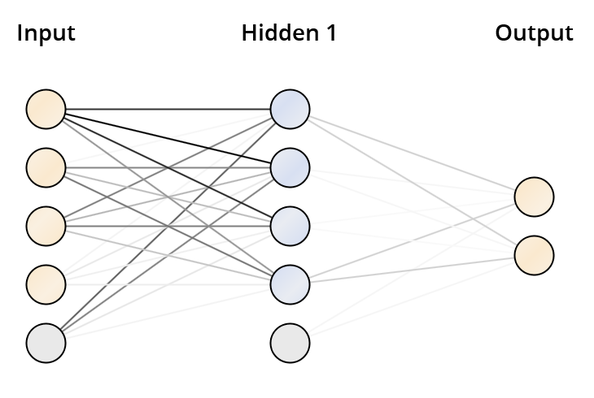

IDPT OPP9

# **DeepLearning**

Model Metrics Type: Binomial  
 Description: Metrics reported on temporary training frame with 10024 samples  
 model id: rm-h2o-model-deep_learning-656443  
 frame id: rm-h2o-frame-deep_learning-656291.temporary.sample.31.45%  
 MSE: 0.04517712  
 R^2: 0.40053228  
 AUC: 0.9789209  
 logloss: 0.2329755  
 CM: Confusion Matrix (vertical: actual; across: predicted):  
 M W Error Rate  
 M 8884 317 0.0345 = 317 / 9,201  
 W 119 704 0.1446 = 119 / 823  
Totals 9003 1021 0.0435 = 436 / 10,024  
Gains/Lift Table (Avg response rate: 8.21 %):  
 Group Cumulative Data Fraction Lower Threshold Lift Cumulative Lift Response Rate Cumulative Response Rate Capture Rate Cumulative Capture Rate Gain Cumulative Gain  
 1 0.01007582 0.989662 12.179830 12.179830 1.000000 1.000000 0.122722 0.122722 1117.982989 1117.982989  
 2 0.02015164 0.931519 12.179830 12.179830 1.000000 1.000000 0.122722 0.245443 1117.982989 1117.982989  
 3 0.03092578 0.700734 10.713739 11.669063 0.879630 0.958065 0.115431 0.360875 971.373926 1066.906283  
 4 0.04150040 0.532712 6.894243 10.452402 0.566038 0.858173 0.072904 0.433779 589.424333 945.240209  
 5 0.05057861 0.373919 8.432190 10.089800 0.692308 0.828402 0.076549 0.510328 743.218992 908.979991  
 6 0.10185555 0.005392 6.729711 8.398237 0.552529 0.689520 0.345079 0.855407 572.971146 739.823726  
 7 0.15003990 0.000160 1.664325 6.235684 0.136646 0.511968 0.080194 0.935601 66.432458 523.568419  
 8 0.20071828 0.000035 1.078922 4.933679 0.088583 0.405070 0.054678 0.990279 7.892194 393.367861  
 9 0.30277334 0.000001 0.095248 3.302801 0.007820 0.271170 0.009721 1.000000 -90.475206 230.280066  
 10 0.40053871 0.000000 0.000000 2.496638 0.000000 0.204981 0.000000 1.000000 -100.000000 149.663761  
 11 0.50029928 0.000000 0.000000 1.998804 0.000000 0.164108 0.000000 1.000000 -100.000000 99.880359  
 12 0.60035914 0.000000 0.000000 1.665670 0.000000 0.136756 0.000000 1.000000 -100.000000 66.566966  
 13 0.70121708 0.000000 0.000000 1.426092 0.000000 0.117086 0.000000 1.000000 -100.000000 42.609190  
 14 0.80047885 0.000000 0.000000 1.249252 0.000000 0.102567 0.000000 1.000000 -100.000000 24.925224  
 15 0.90133679 0.000000 0.000000 1.109463 0.000000 0.091090 0.000000 1.000000 -100.000000 10.946320  
 16 1.00000000 0.000000 0.000000 1.000000 0.000000 0.082103 0.000000 1.000000 -100.000000 0.000000  
Status of Neuron Layers (predicting idpt_ws_opp10, 2-class classification, bernoulli distribution, CrossEntropy loss, 2,902 weights/biases, 38.8 KB, 318,010 training samples, mini-batch size 1):  
 Layer Units Type Dropout L1 L2 Mean Rate Rate RMS Momentum Mean Weight Weight RMS Mean Bias Bias RMS  
 1 4 Input 0.00 %   
 2 50 Rectifier 0.00 % 0.000010 0.000000 0.946973 0.190843 0.000000 -0.010797 0.165852 0.508778 0.052289  
 3 50 Rectifier 0.00 % 0.000010 0.000000 0.866498 0.284761 0.000000 0.005988 0.122893 0.977989 0.031215  
 4 2 Softmax 0.000010 0.000000 0.828621 0.336234 0.000000 0.085809 0.425642 -0.000003 0.000003  
Scoring History:  
 Timestamp Duration Training Speed Epochs Iterations Samples Training MSE Training R^2 Training LogLoss Training AUC Training Lift Training Classification Error  
 2018-04-18 12:08:22 0.000 sec 0.00000 0 0.000000 NaN NaN NaN NaN NaN NaN  
 2018-04-18 12:08:23 1.819 sec 18286 rows/sec 1.00000 1 31801.000000 0.04518 0.40053 0.23298 0.97892 12.17983 0.04350  
 2018-04-18 12:08:29 7.363 sec 17625 rows/sec 4.00000 4 127204.000000 0.05647 0.25069 0.32102 0.97785 12.17983 0.04300  
 2018-04-18 12:08:35 12.991 sec 17418 rows/sec 7.00000 7 222607.000000 0.05896 0.21765 0.34530 0.97716 12.17983 0.04729  
 2018-04-18 12:08:40 18.648 sec 17324 rows/sec 10.00000 10 318010.000000 0.06264 0.16880 0.39353 0.97683 12.17983 0.05537  
 2018-04-18 12:08:40 18.714 sec 17323 rows/sec 10.00000 10 318010.000000 0.04518 0.40053 0.23298 0.97892 12.17983 0.04350  
  
H2O version: 3.8.2.6-rm7.6.1

# **ImprovedNeuralNet**

Hidden 1  
========  
  
Node 1 (Sigmoid)  
----------------  
idpt_ave_correct_opp9: 26.134  
idpt_maxhint_opp9: -8.293  
idpt_sumduration_opp9: 7.479  
pt_ave_correct_opp9: 9.674  
Bias: -4.791  
  
Node 2 (Sigmoid)  
----------------  
idpt_ave_correct_opp9: 37.027  
idpt_maxhint_opp9: -68.834  
idpt_sumduration_opp9: 22.554  
pt_ave_correct_opp9: -7.232  
Bias: -42.634  
  
Node 3 (Sigmoid)  
----------------  
idpt_ave_correct_opp9: 12.096  
idpt_maxhint_opp9: 13.865  
idpt_sumduration_opp9: 10.876  
pt_ave_correct_opp9: -10.176  
Bias: 4.173  
  
Node 4 (Sigmoid)  
----------------  
idpt_ave_correct_opp9: 62.646  
idpt_maxhint_opp9: 15.050  
idpt_sumduration_opp9: -25.846  
pt_ave_correct_opp9: -1.690  
Bias: -20.644  
  
  
Output  
======  
  
Class 'M' (Sigmoid)  
-------------------  
Node 1: 4.662  
Node 2: 2.632  
Node 3: 11.825  
Node 4: 4.656  
Threshold: -5.238  
  
Class 'W' (Sigmoid)  
-------------------  
Node 1: -4.662  
Node 2: -2.632  
Node 3: -11.825  
Node 4: -4.656  
Threshold: 5.238

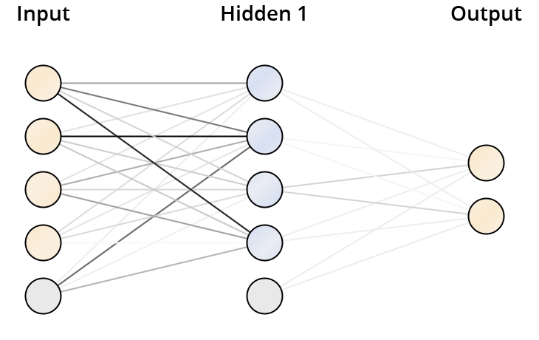

OVERALL_idpt

# **DeepLearning**

Model Metrics Type: Binomial  
 Description: Metrics reported on temporary training frame with 9912 samples  
 model id: rm-h2o-model-deep_learning-372888  
 frame id: rm-h2o-frame-deep_learning-232514.temporary.sample.31.45%  
 MSE: 0.08099742  
 R^2: -0.012654896  
 AUC: 0.8568675  
 logloss: 0.4941286  
 CM: Confusion Matrix (vertical: actual; across: predicted):  
 M W Error Rate  
 M 6960 2083 0.2303 = 2,083 / 9,043  
 W 163 706 0.1876 = 163 / 869  
Totals 7123 2789 0.2266 = 2,246 / 9,912  
Gains/Lift Table (Avg response rate: 8.77 %):  
 Group Cumulative Data Fraction Lower Threshold Lift Cumulative Lift Response Rate Cumulative Response Rate Capture Rate Cumulative Capture Rate Gain Cumulative Gain  
 1 0.01099677 0.139718 7.952957 7.952957 0.697248 0.697248 0.087457 0.087457 695.295658 695.295658  
 2 0.02007667 0.095290 4.815957 6.534213 0.422222 0.572864 0.043728 0.131185 381.595704 553.421307  
 3 0.03087167 0.083328 5.436607 6.150410 0.476636 0.539216 0.058688 0.189873 443.660669 515.040953  
 4 0.04015335 0.075001 0.000000 4.728707 0.000000 0.414573 0.000000 0.189873 -100.000000 372.870683  
 5 0.05185634 0.057443 4.031507 4.571362 0.353448 0.400778 0.047181 0.237054 303.150669 357.136205  
 6 0.10098870 0.019343 3.115044 3.862844 0.273101 0.338661 0.153049 0.390104 211.504408 286.284372  
 7 0.15022195 0.004650 1.706257 3.156051 0.149590 0.276696 0.084005 0.474108 70.625743 215.605116  
 8 0.20298628 0.001596 1.744736 2.789193 0.152964 0.244533 0.092060 0.566168 74.473637 178.919349  
 9 0.30034302 0.000182 2.576741 2.720326 0.225907 0.238495 0.250863 0.817031 157.674058 172.032649  
 10 0.40022195 0.000039 1.244314 2.351975 0.109091 0.206201 0.124281 0.941312 24.431426 135.197456  
 11 0.50010089 0.000008 0.322600 1.946673 0.028283 0.170668 0.032221 0.973533 -67.740001 94.667280  
 12 0.59997982 0.000002 0.264993 1.666723 0.023232 0.146124 0.026467 1.000000 -73.500715 66.672272  
 13 0.70106941 0.000001 0.000000 1.426392 0.000000 0.125054 0.000000 1.000000 -100.000000 42.639229  
 14 0.80094835 0.000000 0.000000 1.248520 0.000000 0.109460 0.000000 1.000000 -100.000000 24.851996  
 15 0.90042373 0.000000 0.000000 1.110588 0.000000 0.097367 0.000000 1.000000 -100.000000 11.058824  
 16 1.00000000 0.000000 0.000000 1.000000 0.000000 0.087672 0.000000 1.000000 -100.000000 0.000000  
Status of Neuron Layers (predicting idpt_ws_opp10, 2-class classification, bernoulli distribution, CrossEntropy loss, 2,902 weights/biases, 38.8 KB, 318,010 training samples, mini-batch size 1):  
 Layer Units Type Dropout L1 L2 Mean Rate Rate RMS Momentum Mean Weight Weight RMS Mean Bias Bias RMS  
 1 4 Input 0.00 %   
 2 50 Rectifier 0.00 % 0.000010 0.000000 0.875559 0.316821 0.000000 -0.051923 0.183792 0.393878 0.228912  
 3 50 Rectifier 0.00 % 0.000010 0.000000 0.679628 0.423995 0.000000 -0.009976 0.147181 0.789298 0.227587  
 4 2 Softmax 0.000010 0.000000 0.740421 0.397046 0.000000 0.000628 0.424232 0.000005 0.003121  
Scoring History:  
 Timestamp Duration Training Speed Epochs Iterations Samples Training MSE Training R^2 Training LogLoss Training AUC Training Lift Training Classification Error  
 2018-04-18 12:20:07 0.000 sec 0.00000 0 0.000000 NaN NaN NaN NaN NaN NaN  
 2018-04-18 12:20:09 1.786 sec 18629 rows/sec 1.00000 1 31801.000000 0.08374 -0.04690 0.54997 0.86654 3.50960 0.14316  
 2018-04-18 12:20:14 6.836 sec 19008 rows/sec 4.00000 4 127204.000000 0.08424 -0.05314 0.52125 0.85841 1.55036 0.13247  
 2018-04-18 12:20:20 13.030 sec 19846 rows/sec 8.00000 8 254408.000000 0.08100 -0.01265 0.49413 0.85687 7.95296 0.22659  
 2018-04-18 12:20:23 15.945 sec 20294 rows/sec 10.00000 10 318010.000000 0.08495 -0.06208 0.57406 0.86100 8.22069 0.11642  
 2018-04-18 12:20:23 16.010 sec 20292 rows/sec 10.00000 10 318010.000000 0.08100 -0.01265 0.49413 0.85687 7.95296 0.22659  
  
H2O version: 3.8.2.6-rm7.6.1

# **ImprovedNeuralNet**

Hidden 1  
========  
  
Node 1 (Sigmoid)  
----------------  
idpt_ave_correct_all: 45.234  
idpt_maxhint_all: 38.737  
idpt_sumduration_all: -48.236  
pt_ave_correct_all: -14.001  
Bias: -29.353  
  
Node 2 (Sigmoid)  
----------------  
idpt_ave_correct_all: 89.539  
idpt_maxhint_all: 24.615  
idpt_sumduration_all: 9.535  
pt_ave_correct_all: 13.005  
Bias: -40.750  
  
Node 3 (Sigmoid)  
----------------  
idpt_ave_correct_all: 13.712  
idpt_maxhint_all: 1.328  
idpt_sumduration_all: -0.379  
pt_ave_correct_all: -18.537  
Bias: -11.338  
  
Node 4 (Sigmoid)  
----------------  
idpt_ave_correct_all: -3.420  
idpt_maxhint_all: -78.788  
idpt_sumduration_all: 12.084  
pt_ave_correct_all: 17.250  
Bias: -53.835  
  
  
Output  
======  
  
Class 'M' (Sigmoid)  
-------------------  
Node 1: 15.209  
Node 2: 17.777  
Node 3: 12.970  
Node 4: 2.450  
Threshold: -0.684  
  
Class 'W' (Sigmoid)  
-------------------  
Node 1: -15.209  
Node 2: -17.777  
Node 3: -12.970  
Node 4: -2.450  
Threshold: 0.684

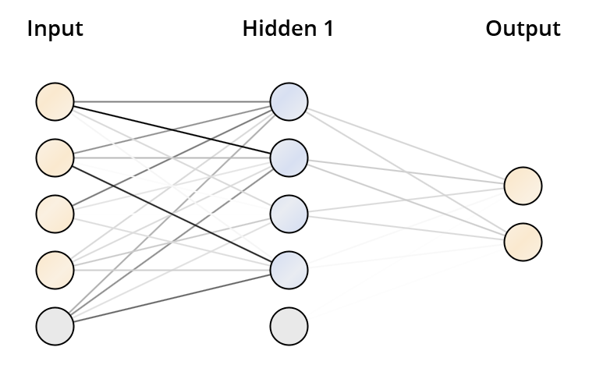

IDKC OPP3

# **DeepLearning**

Model Metrics Type: Binomial  
 Description: Metrics reported on temporary training frame with 9935 samples  
 model id: rm-h2o-model-deep_learning-564097  
 frame id: rm-h2o-frame-deep_learning-640203.temporary.sample.37.64%  
 MSE: 0.014795752  
 R^2: -0.014989405  
 AUC: 0.33630693  
 logloss: 0.16508768  
 CM: Confusion Matrix (vertical: actual; across: predicted):  
 M W Error Rate  
 M 42 9746 0.9957 = 9,746 / 9,788  
 W 0 147 0.0000 = 0 / 147  
Totals 42 9893 0.9810 = 9,746 / 9,935  
Gains/Lift Table (Avg response rate: 1.48 %):  
 Group Cumulative Data Fraction Lower Threshold Lift Cumulative Lift Response Rate Cumulative Response Rate Capture Rate Cumulative Capture Rate Gain Cumulative Gain  
 1 0.01006543 0.000015 0.000000 0.000000 0.000000 0.000000 0.000000 0.000000 -100.000000 -100.000000  
 2 0.02123805 0.000015 0.000000 0.000000 0.000000 0.000000 0.000000 0.000000 -100.000000 -100.000000  
 3 0.03190740 0.000015 0.000000 0.000000 0.000000 0.000000 0.000000 0.000000 -100.000000 -100.000000  
 4 0.04056366 0.000015 2.357617 0.503114 0.034884 0.007444 0.020408 0.020408 135.761747 -49.688560  
 5 0.05113236 0.000015 0.000000 0.399124 0.000000 0.005906 0.000000 0.020408 -100.000000 -60.087578  
 6 0.10135883 0.000015 0.000000 0.201346 0.000000 0.002979 0.000000 0.020408 -100.000000 -79.865432  
 7 0.15218923 0.000015 0.802991 0.402292 0.011881 0.005952 0.040816 0.061224 -19.700950 -59.770813  
 8 0.20020131 0.000015 0.000000 0.305815 0.000000 0.004525 0.000000 0.061224 -100.000000 -69.418537  
 9 0.30156014 0.000014 0.536922 0.383493 0.007944 0.005674 0.054422 0.115646 -46.307818 -61.650682  
 10 0.40050327 0.000014 2.062615 0.798315 0.030519 0.011812 0.204082 0.319728 106.261548 -20.168469  
 11 0.50478108 0.000014 0.000000 0.633399 0.000000 0.009372 0.000000 0.319728 -100.000000 -36.660088  
 12 0.60513337 0.000014 0.610096 0.629535 0.009027 0.009315 0.061224 0.380952 -38.990441 -37.046542  
 13 0.70015098 0.000014 1.073915 0.689841 0.015890 0.010207 0.102041 0.482993 7.391474 -31.015851  
 14 0.80110720 0.000014 0.471680 0.662349 0.006979 0.009800 0.047619 0.530612 -52.831980 -33.765138  
 15 0.90085556 0.000014 1.500374 0.755140 0.022200 0.011173 0.149660 0.680272 50.037412 -24.485996  
 16 1.00000000 0.000013 3.224870 1.000000 0.047716 0.014796 0.319728 1.000000 222.486964 0.000000  
Status of Neuron Layers (predicting IDKC WS_10, 2-class classification, bernoulli distribution, CrossEntropy loss, 2,902 weights/biases, 38.8 KB, 265,640 training samples, mini-batch size 1):  
 Layer Units Type Dropout L1 L2 Mean Rate Rate RMS Momentum Mean Weight Weight RMS Mean Bias Bias RMS  
 1 4 Input 0.00 %   
 2 50 Rectifier 0.00 % 0.000010 0.000000 1.003320 0.000154 0.000000 -0.010168 0.024911 0.203379 0.105685  
 3 50 Rectifier 0.00 % 0.000010 0.000000 0.936281 0.227704 0.000000 -0.002885 0.023007 0.541059 0.219108  
 4 2 Softmax 0.000010 0.000000 0.930129 0.246842 0.000000 -0.005582 0.317015 -0.000034 0.057343  
Scoring History:  
 Timestamp Duration Training Speed Epochs Iterations Samples Training MSE Training R^2 Training LogLoss Training AUC Training Lift Training Classification Error  
 2018-04-18 12:36:32 0.000 sec 0.00000 0 0.000000 NaN NaN NaN NaN NaN NaN  
 2018-04-18 12:36:33 1.623 sec 17193 rows/sec 1.00000 1 26564.000000 0.01480 -0.01501 0.18876 0.38696 0.00000 0.07690  
 2018-04-18 12:36:38 6.703 sec 16214 rows/sec 4.00000 4 106256.000000 0.01480 -0.01499 0.16509 0.33631 0.00000 0.98098  
 2018-04-18 12:36:44 12.199 sec 19944 rows/sec 9.00000 9 239076.000000 0.01480 -0.01500 0.17273 0.66466 1.96850 0.09763  
 2018-04-18 12:36:45 13.130 sec 20667 rows/sec 10.00000 10 265640.000000 0.01480 -0.01500 0.17733 0.70699 5.40680 0.08083  
 2018-04-18 12:36:45 13.194 sec 20665 rows/sec 10.00000 10 265640.000000 0.01480 -0.01499 0.16509 0.33631 0.00000 0.98098  
  
H2O version: 3.8.2.6-rm7.6.1

IDKC OPP3

# **ImprovedNeuralNet**

Hidden 1  
========  
  
Node 1 (Sigmoid)  
----------------  
idkc_average_correct_3: -1.680  
idkc_max_hint_3: 8.516  
idkc_sum_duration_3: 4.545  
kc_ave_correct_3: -0.609  
Bias: 2.228  
  
Node 2 (Sigmoid)  
----------------  
idkc_average_correct_3: -5.555  
idkc_max_hint_3: -0.243  
idkc_sum_duration_3: 4.720  
kc_ave_correct_3: -6.094  
Bias: -3.412  
  
Node 3 (Sigmoid)  
----------------  
idkc_average_correct_3: 6.346  
idkc_max_hint_3: 5.344  
idkc_sum_duration_3: -7.716  
kc_ave_correct_3: 6.755  
Bias: 1.793  
  
Node 4 (Sigmoid)  
----------------  
idkc_average_correct_3: 2.511  
idkc_max_hint_3: -13.173  
idkc_sum_duration_3: 0.320  
kc_ave_correct_3: -1.316  
Bias: -11.064  
  
  
Output  
======  
  
Class 'M' (Sigmoid)  
-------------------  
Node 1: 4.676  
Node 2: 3.170  
Node 3: 4.437  
Node 4: 4.272  
Threshold: -1.146  
  
Class 'W' (Sigmoid)  
-------------------  
Node 1: -4.677  
Node 2: -3.170  
Node 3: -4.437  
Node 4: -4.272  
Threshold: 1.146

OPP4

# **DeepLearning**

Model Metrics Type: Binomial  
 Description: Metrics reported on temporary training frame with 10100 samples  
 model id: rm-h2o-model-deep_learning-28312  
 frame id: rm-h2o-frame-deep_learning-291934.temporary.sample.37.64%  
 MSE: 0.014950114  
 R^2: -0.015151565  
 AUC: 0.4193343  
 logloss: 0.1685292  
 CM: Confusion Matrix (vertical: actual; across: predicted):  
 M W Error Rate  
 M 9529 420 0.0422 = 420 / 9,949  
 W 134 17 0.8874 = 134 / 151  
Totals 9663 437 0.0549 = 554 / 10,100  
Gains/Lift Table (Avg response rate: 1.50 %):  
 Group Cumulative Data Fraction Lower Threshold Lift Cumulative Lift Response Rate Cumulative Response Rate Capture Rate Cumulative Capture Rate Gain Cumulative Gain  
 1 0.01386139 0.000013 1.911069 1.911069 0.028571 0.028571 0.026490 0.026490 91.106906 91.106906  
 2 0.02029703 0.000013 3.087112 2.283961 0.046154 0.034146 0.019868 0.046358 208.711156 128.396059  
 3 0.03277228 0.000013 0.000000 1.414538 0.000000 0.021148 0.000000 0.046358 -100.000000 41.453752  
 4 0.04326733 0.000013 6.310134 2.602028 0.094340 0.038902 0.066225 0.112583 531.013370 160.202767  
 5 0.05138614 0.000013 1.631400 2.448672 0.024390 0.036609 0.013245 0.125828 63.140042 144.867231  
 6 0.10069307 0.000013 1.477433 1.973080 0.022088 0.029499 0.072848 0.198675 47.743291 97.308015  
 7 0.15247525 0.000013 0.000000 1.303002 0.000000 0.019481 0.000000 0.198675 -100.000000 30.300163  
 8 0.20178218 0.000013 1.074497 1.247165 0.016064 0.018646 0.052980 0.251656 7.449666 24.716480  
 9 0.30148515 0.000013 0.464957 0.988484 0.006951 0.014778 0.046358 0.298013 -53.504278 -1.151600  
 10 0.40009901 0.000013 0.201468 0.794505 0.003012 0.011878 0.019868 0.317881 -79.853188 -20.549467  
 11 0.50069307 0.000013 0.987511 0.833282 0.014764 0.012458 0.099338 0.417219 -1.248892 -16.671796  
 12 0.60118812 0.000013 0.197697 0.727037 0.002956 0.010870 0.019868 0.437086 -80.230320 -27.296286  
 13 0.70059406 0.000013 0.666209 0.718406 0.009960 0.010741 0.066225 0.503311 -33.379067 -28.159360  
 14 0.80000000 0.000013 0.666209 0.711921 0.009960 0.010644 0.066225 0.569536 -33.379067 -28.807947  
 15 0.90039604 0.000012 1.649098 0.816418 0.024655 0.012206 0.165563 0.735099 64.909806 -18.358222  
 16 1.00000000 0.000012 2.659539 1.000000 0.039761 0.014950 0.264901 1.000000 165.953945 0.000000  
Status of Neuron Layers (predicting IDKC WS_10, 2-class classification, bernoulli distribution, CrossEntropy loss, 2,902 weights/biases, 38.7 KB, 265,640 training samples, mini-batch size 1):  
 Layer Units Type Dropout L1 L2 Mean Rate Rate RMS Momentum Mean Weight Weight RMS Mean Bias Bias RMS  
 1 4 Input 0.00 %   
 2 50 Rectifier 0.00 % 0.000010 0.000000 1.003267 0.000212 0.000000 -0.004289 0.011832 0.179759 0.090072  
 3 50 Rectifier 0.00 % 0.000010 0.000000 1.002963 0.002980 0.000000 -0.002699 0.023091 0.576970 0.226095  
 4 2 Softmax 0.000010 0.000000 1.003477 0.002062 0.000000 -0.021650 0.340440 -0.000039 0.065324  
Scoring History:  
 Timestamp Duration Training Speed Epochs Iterations Samples Training MSE Training R^2 Training LogLoss Training AUC Training Lift Training Classification Error  
 2018-04-18 12:52:30 0.000 sec 0.00000 0 0.000000 NaN NaN NaN NaN NaN NaN  
 2018-04-18 12:52:32 1.652 sec 16887 rows/sec 1.00000 1 26564.000000 0.01495 -0.01516 0.17284 0.77574 8.60927 0.03307  
 2018-04-18 12:52:37 6.825 sec 15908 rows/sec 4.00000 4 106256.000000 0.01495 -0.01515 0.16853 0.41933 1.91107 0.05485  
 2018-04-18 12:52:43 12.784 sec 19018 rows/sec 9.00000 9 239076.000000 0.01495 -0.01517 0.19094 0.42330 0.00000 0.05564  
 2018-04-18 12:52:44 13.710 sec 19776 rows/sec 10.00000 10 265640.000000 0.01495 -0.01515 0.17542 0.59032 0.00000 0.39307  
 2018-04-18 12:52:44 13.777 sec 19775 rows/sec 10.00000 10 265640.000000 0.01495 -0.01515 0.16853 0.41933 1.91107 0.05485  
  
H2O version: 3.8.2.6-rm7.6.1

# **ImprovedNeuralNet**

Hidden 1  
========  
  
Node 1 (Sigmoid)  
----------------  
idkc_average_correct_4: 3.059  
idkc_max_hint_4: 9.929  
idkc_sum_duration_4: -1.933  
kc_ave_correct_4: -2.949  
Bias: 0.579  
  
Node 2 (Sigmoid)  
----------------  
idkc_average_correct_4: -7.224  
idkc_max_hint_4: -3.630  
idkc_sum_duration_4: 10.113  
kc_ave_correct_4: -1.831  
Bias: -5.970  
  
Node 3 (Sigmoid)  
----------------  
idkc_average_correct_4: 1.541  
idkc_max_hint_4: 2.625  
idkc_sum_duration_4: -6.807  
kc_ave_correct_4: 4.810  
Bias: -4.782  
  
Node 4 (Sigmoid)  
----------------  
idkc_average_correct_4: -0.605  
idkc_max_hint_4: -16.655  
idkc_sum_duration_4: 0.170  
kc_ave_correct_4: -0.754  
Bias: -13.867  
  
  
Output  
======  
  
Class 'M' (Sigmoid)  
-------------------  
Node 1: 3.479  
Node 2: 4.394  
Node 3: 2.146  
Node 4: 3.523  
Threshold: 0.976  
  
Class 'W' (Sigmoid)  
-------------------  
Node 1: -3.479  
Node 2: -4.394  
Node 3: -2.146  
Node 4: -3.523  
Threshold: -0.976

OPP5

# **DeepLearning**

Model Metrics Type: Binomial  
 Description: Metrics reported on temporary training frame with 9956 samples  
 model id: rm-h2o-model-deep_learning-704471  
 frame id: rm-h2o-frame-deep_learning-893655.temporary.sample.37.64%  
 MSE: 0.014061631  
 R^2: -0.01424504  
 AUC: 0.7505945  
 logloss: 0.16976628  
 CM: Confusion Matrix (vertical: actual; across: predicted):  
 M W Error Rate  
 M 9647 169 0.0172 = 169 / 9,816  
 W 119 21 0.8500 = 119 / 140  
Totals 9766 190 0.0289 = 288 / 9,956  
Gains/Lift Table (Avg response rate: 1.41 %):  
 Group Cumulative Data Fraction Lower Threshold Lift Cumulative Lift Response Rate Cumulative Response Rate Capture Rate Cumulative Capture Rate Gain Cumulative Gain  
 1 0.01074729 0.000024 2.658478 2.658478 0.037383 0.037383 0.028571 0.028571 165.847797 165.847797  
 2 0.02018883 0.000021 12.861094 7.429851 0.180851 0.104478 0.121429 0.150000 1186.109422 642.985075  
 3 0.03023303 0.000017 2.844571 5.906502 0.040000 0.083056 0.028571 0.178571 184.457143 490.650214  
 4 0.04007634 0.000016 3.628280 5.346939 0.051020 0.075188 0.035714 0.214286 262.827988 434.693878  
 5 0.05052230 0.000014 2.735165 4.806930 0.038462 0.067594 0.028571 0.242857 173.516484 380.692985  
 6 0.10014062 0.000009 1.727473 3.281100 0.024291 0.046138 0.085714 0.328571 72.747253 228.110044  
 7 0.15016071 0.000007 1.427998 2.663813 0.020080 0.037458 0.071429 0.400000 42.799771 166.381271  
 8 0.20028124 0.000005 2.565245 2.639146 0.036072 0.037111 0.128571 0.528571 156.524478 163.914601  
 9 0.30012053 0.000004 1.717045 2.332396 0.024145 0.032798 0.171429 0.700000 71.704513 133.239625  
 10 0.40216955 0.000002 0.069994 1.758320 0.000984 0.024725 0.007143 0.707143 -93.000562 75.832025  
 11 0.50080354 0.000002 1.448356 1.697272 0.020367 0.023867 0.142857 0.850000 44.835612 69.727236  
 12 0.60255123 0.000002 0.280807 1.458086 0.003949 0.020503 0.028571 0.878571 -71.919334 45.808587  
 13 0.69997991 0.000002 0.293255 1.295956 0.004124 0.018224 0.028571 0.907143 -70.674521 29.595556  
 14 0.80202893 0.000001 0.559955 1.202308 0.007874 0.016907 0.057143 0.964286 -44.004499 20.230790  
 15 0.90237043 0.000000 0.355927 1.108192 0.005005 0.015583 0.035714 1.000000 -64.407264 10.819234  
 16 1.00000000 0.000000 0.000000 1.000000 0.000000 0.014062 0.000000 1.000000 -100.000000 0.000000  
Status of Neuron Layers (predicting IDKC WS_10, 2-class classification, bernoulli distribution, CrossEntropy loss, 2,902 weights/biases, 38.8 KB, 265,640 training samples, mini-batch size 1):  
 Layer Units Type Dropout L1 L2 Mean Rate Rate RMS Momentum Mean Weight Weight RMS Mean Bias Bias RMS  
 1 4 Input 0.00 %   
 2 50 Rectifier 0.00 % 0.000010 0.000000 1.003233 0.000121 0.000000 0.000385 0.090567 0.419731 0.061337  
 3 50 Rectifier 0.00 % 0.000010 0.000000 0.984131 0.130669 0.000000 0.000250 0.056529 0.876158 0.038457  
 4 2 Softmax 0.000010 0.000000 0.988621 0.102853 0.000000 0.052893 0.375166 -0.000002 0.000007  
Scoring History:  
 Timestamp Duration Training Speed Epochs Iterations Samples Training MSE Training R^2 Training LogLoss Training AUC Training Lift Training Classification Error  
 2018-04-18 14:30:36 0.000 sec 0.00000 0 0.000000 NaN NaN NaN NaN NaN NaN  
 2018-04-18 14:30:38 1.990 sec 23342 rows/sec 1.00000 1 26564.000000 0.01406 -0.01425 0.16977 0.75059 2.65848 0.02893  
 2018-04-18 14:30:43 7.014 sec 26231 rows/sec 6.00000 6 159384.000000 0.01406 -0.01425 0.17084 0.52795 0.00000 0.08688  
 2018-04-18 14:30:46 10.058 sec 29368 rows/sec 10.00000 10 265640.000000 0.01406 -0.01425 0.17419 0.51101 0.00000 0.08477  
 2018-04-18 14:30:46 10.135 sec 29352 rows/sec 10.00000 10 265640.000000 0.01406 -0.01425 0.16977 0.75059 2.65848 0.02893  
  
H2O version: 3.8.2.6-rm7.6.1

# **ImprovedNeuralNet**

Hidden 1  
========  
  
Node 1 (Sigmoid)  
----------------  
idkc_average_correct_5: 15.940  
idkc_max_hint_5: -17.069  
idkc_sum_duration_5: 4.041  
kc_ave_correct_5: -9.417  
Bias: -6.637  
  
Node 2 (Sigmoid)  
----------------  
idkc_average_correct_5: -20.642  
idkc_max_hint_5: 9.670  
idkc_sum_duration_5: 18.742  
kc_ave_correct_5: 1.276  
Bias: 3.571  
  
Node 3 (Sigmoid)  
----------------  
idkc_average_correct_5: 12.185  
idkc_max_hint_5: -10.164  
idkc_sum_duration_5: 12.439  
kc_ave_correct_5: 10.298  
Bias: -2.457  
  
Node 4 (Sigmoid)  
----------------  
idkc_average_correct_5: 0.673  
idkc_max_hint_5: -9.738  
idkc_sum_duration_5: -9.500  
kc_ave_correct_5: -1.980  
Bias: -14.785  
  
  
Output  
======  
  
Class 'M' (Sigmoid)  
-------------------  
Node 1: 6.453  
Node 2: 11.055  
Node 3: 7.692  
Node 4: 2.188  
Threshold: -4.861  
  
Class 'W' (Sigmoid)  
-------------------  
Node 1: -6.453  
Node 2: -11.055  
Node 3: -7.692  
Node 4: -2.188  
Threshold: 4.861

OPP6

# **DeepLearning**

Model Metrics Type: Binomial  
 Description: Metrics reported on temporary training frame with 9992 samples  
 model id: rm-h2o-model-deep_learning-616455  
 frame id: rm-h2o-frame-deep_learning-836056.temporary.sample.37.64%  
 MSE: 0.0159124  
 R^2: -0.016148997  
 AUC: 0.7012141  
 logloss: 0.18841596  
 CM: Confusion Matrix (vertical: actual; across: predicted):  
 M W Error Rate  
 M 9445 388 0.0395 = 388 / 9,833  
 W 112 47 0.7044 = 112 / 159  
Totals 9557 435 0.0500 = 500 / 9,992  
Gains/Lift Table (Avg response rate: 1.59 %):  
 Group Cumulative Data Fraction Lower Threshold Lift Cumulative Lift Response Rate Cumulative Response Rate Capture Rate Cumulative Capture Rate Gain Cumulative Gain  
 1 0.01000801 0.000027 6.912704 6.912704 0.110000 0.110000 0.069182 0.069182 591.270440 591.270440  
 2 0.02051641 0.000023 1.795508 4.291701 0.028571 0.068293 0.018868 0.088050 79.550764 329.170118  
 3 0.03052442 0.000017 3.142138 3.914795 0.050000 0.062295 0.031447 0.119497 214.213836 291.479534  
 4 0.04043235 0.000015 12.060733 5.910953 0.191919 0.094059 0.119497 0.238994 1106.073312 491.095336  
 5 0.05034027 0.000014 8.886856 6.496668 0.141414 0.103380 0.088050 0.327044 788.685598 549.666779  
 6 0.10068054 0.000009 2.498718 4.497693 0.039761 0.071571 0.125786 0.452830 149.871838 349.769309  
 7 0.15222178 0.000006 0.732149 3.222706 0.011650 0.051282 0.037736 0.490566 -26.785125 222.270602  
 8 0.20006005 0.000006 0.657351 2.609279 0.010460 0.041521 0.031447 0.522013 -34.264888 160.927948  
 9 0.30014011 0.000005 0.188528 1.802093 0.003000 0.028676 0.018868 0.540881 -81.147170 80.209336  
 10 0.40012010 0.000003 0.125811 1.383232 0.002002 0.022011 0.012579 0.553459 -87.418865 38.323250  
 11 0.50010008 0.000003 2.012982 1.509132 0.032032 0.024014 0.201258 0.754717 101.298153 50.913189  
 12 0.60338271 0.000003 0.974306 1.417584 0.015504 0.022558 0.100629 0.855346 -2.569353 41.758440  
 13 0.70326261 0.000003 0.251875 1.252026 0.004008 0.019923 0.025157 0.880503 -74.812518 25.202610  
 14 0.80034027 0.000003 0.000000 1.100161 0.000000 0.017507 0.000000 0.880503 -100.000000 10.016099  
 15 0.90012010 0.000003 0.693350 1.055065 0.011033 0.016789 0.069182 0.949686 -30.664951 5.506536  
 16 1.00000000 0.000001 0.503750 1.000000 0.008016 0.015913 0.050314 1.000000 -49.625036 0.000000  
Status of Neuron Layers (predicting IDKC WS_10, 2-class classification, bernoulli distribution, CrossEntropy loss, 2,902 weights/biases, 38.8 KB, 265,640 training samples, mini-batch size 1):  
 Layer Units Type Dropout L1 L2 Mean Rate Rate RMS Momentum Mean Weight Weight RMS Mean Bias Bias RMS  
 1 4 Input 0.00 %   
 2 50 Rectifier 0.00 % 0.000010 0.000000 0.954268 0.182769 0.000000 -0.024253 0.057639 0.163567 0.238810  
 3 50 Rectifier 0.00 % 0.000010 0.000000 0.562645 0.446942 0.000000 -0.011923 0.046820 0.764194 0.857285  
 4 2 Softmax 0.000010 0.000000 0.592243 0.449023 0.000000 -0.002620 0.338336 -0.000001 0.000009  
Scoring History:  
 Timestamp Duration Training Speed Epochs Iterations Samples Training MSE Training R^2 Training LogLoss Training AUC Training Lift Training Classification Error  
 2018-04-18 14:46:07 0.000 sec 0.00000 0 0.000000 NaN NaN NaN NaN NaN NaN  
 2018-04-18 14:46:08 1.080 sec 26564 rows/sec 1.00000 1 26564.000000 0.01591 -0.01615 0.18939 0.67470 4.39899 0.06085  
 2018-04-18 14:46:13 6.364 sec 29895 rows/sec 7.00000 7 185948.000000 0.01591 -0.01616 0.19592 0.52561 0.00000 0.08527  
 2018-04-18 14:46:15 8.107 sec 33638 rows/sec 10.00000 10 265640.000000 0.01591 -0.01615 0.18842 0.70121 6.91270 0.05004  
  
H2O version: 3.8.2.6-rm7.6.1

# **ImprovedNeuralNet**

Hidden 1  
========  
  
Node 1 (Sigmoid)  
----------------  
idkc_average_correct_6: -16.362  
idkc_max_hint_6: 14.219  
idkc_sum_duration_6: 15.907  
kc_ave_correct_6: 2.102  
Bias: 11.905  
  
Node 2 (Sigmoid)  
----------------  
idkc_average_correct_6: -29.798  
idkc_max_hint_6: -20.863  
idkc_sum_duration_6: 9.992  
kc_ave_correct_6: -2.104  
Bias: -17.262  
  
Node 3 (Sigmoid)  
----------------  
idkc_average_correct_6: -0.484  
idkc_max_hint_6: -11.692  
idkc_sum_duration_6: 1.948  
kc_ave_correct_6: 0.710  
Bias: -9.660  
  
Node 4 (Sigmoid)  
----------------  
idkc_average_correct_6: 36.400  
idkc_max_hint_6: -2.138  
idkc_sum_duration_6: -21.350  
kc_ave_correct_6: -0.771  
Bias: -5.997  
  
  
Output  
======  
  
Class 'M' (Sigmoid)  
-------------------  
Node 1: 12.494  
Node 2: 8.212  
Node 3: 5.053  
Node 4: 10.133  
Threshold: -7.343  
  
Class 'W' (Sigmoid)  
-------------------  
Node 1: -12.494  
Node 2: -8.212  
Node 3: -5.053  
Node 4: -10.133  
Threshold: 7.343

Opp7

# **DeepLearning**

Model Metrics Type: Binomial  
 Description: Metrics reported on temporary training frame with 10049 samples  
 model id: rm-h2o-model-deep_learning-80479  
 frame id: rm-h2o-frame-deep_learning-204409.temporary.sample.37.64%  
 MSE: 0.0151254935  
 R^2: -0.015332015  
 AUC: 0.401018  
 logloss: 0.170321  
 CM: Confusion Matrix (vertical: actual; across: predicted):  
 M W Error Rate  
 M 9198 699 0.0706 = 699 / 9,897  
 W 123 29 0.8092 = 123 / 152  
Totals 9321 728 0.0818 = 822 / 10,049  
Gains/Lift Table (Avg response rate: 1.51 %):  
 Group Cumulative Data Fraction Lower Threshold Lift Cumulative Lift Response Rate Cumulative Response Rate Capture Rate Cumulative Capture Rate Gain Cumulative Gain  
 1 0.01024978 0.000013 0.000000 0.000000 0.000000 0.000000 0.000000 0.000000 -100.000000 -100.000000  
 2 0.02010150 0.000013 0.667796 0.327286 0.010101 0.004950 0.006579 0.006579 -33.220362 -67.271365  
 3 0.03015225 0.000013 0.000000 0.218191 0.000000 0.003300 0.000000 0.006579 -100.000000 -78.180910  
 4 0.04080008 0.000013 0.000000 0.161248 0.000000 0.002439 0.000000 0.006579 -100.000000 -83.875160  
 5 0.05085083 0.000013 2.618291 0.646887 0.039604 0.009785 0.026316 0.032895 161.829078 -35.311309  
 6 0.10070654 0.000013 3.694873 2.155821 0.055888 0.032609 0.184211 0.217105 269.487341 115.582094  
 7 0.15076127 0.000013 0.394305 1.570974 0.005964 0.023762 0.019737 0.236842 -60.569478 57.097447  
 8 0.20001990 0.000013 0.934915 1.414333 0.014141 0.021393 0.046053 0.282895 -6.508506 41.433294  
 9 0.30092547 0.000013 0.521592 1.114981 0.007890 0.016865 0.052632 0.335526 -47.840756 11.498146  
 10 0.40003980 0.000013 0.000000 0.838732 0.000000 0.012687 0.000000 0.335526 -100.000000 -16.126767  
 11 0.50004976 0.000013 0.328915 0.736769 0.004975 0.011144 0.032895 0.368421 -67.108536 -26.323121  
 12 0.60095532 0.000013 0.130398 0.634954 0.001972 0.009604 0.013158 0.381579 -86.960189 -36.504606  
 13 0.69997015 0.000013 0.398664 0.601529 0.006030 0.009099 0.039474 0.421053 -60.133563 -39.847059  
 14 0.79998010 0.000013 0.920961 0.641463 0.013930 0.009703 0.092105 0.513158 -7.903902 -35.853667  
 15 0.89999005 0.000013 1.644573 0.752932 0.024876 0.011389 0.164474 0.677632 64.457319 -24.706770  
 16 1.00000000 0.000011 3.223363 1.000000 0.048756 0.015126 0.322368 1.000000 222.336345 0.000000  
Status of Neuron Layers (predicting IDKC WS_10, 2-class classification, bernoulli distribution, CrossEntropy loss, 2,902 weights/biases, 38.7 KB, 265,640 training samples, mini-batch size 1):  
 Layer Units Type Dropout L1 L2 Mean Rate Rate RMS Momentum Mean Weight Weight RMS Mean Bias Bias RMS  
 1 4 Input 0.00 %   
 2 50 Rectifier 0.00 % 0.000010 0.000000 1.003255 0.000036 0.000000 -0.008100 0.028989 0.186039 0.046683  
 3 50 Rectifier 0.00 % 0.000010 0.000000 0.695106 0.412348 0.000000 -0.005571 0.009828 0.342582 0.343799  
 4 2 Softmax 0.000010 0.000000 0.671633 0.448184 0.000000 -0.003818 0.333274 -0.000018 0.214786  
Scoring History:  
 Timestamp Duration Training Speed Epochs Iterations Samples Training MSE Training R^2 Training LogLoss Training AUC Training Lift Training Classification Error  
 2018-04-18 14:56:07 0.000 sec 0.00000 0 0.000000 NaN NaN NaN NaN NaN NaN  
 2018-04-18 14:56:09 1.171 sec 24573 rows/sec 1.00000 1 26564.000000 0.01513 -0.01534 0.17590 0.74408 4.53709 0.04956  
 2018-04-18 14:56:14 6.344 sec 25748 rows/sec 6.00000 6 159384.000000 0.01513 -0.01533 0.17032 0.40102 0.00000 0.08180  
 2018-04-18 14:56:16 8.889 sec 30642 rows/sec 10.00000 10 265640.000000 0.01513 -0.01535 0.18185 0.33844 1.29631 0.02667  
 2018-04-18 14:56:16 8.955 sec 30638 rows/sec 10.00000 10 265640.000000 0.01513 -0.01533 0.17032 0.40102 0.00000 0.08180  
  
H2O version: 3.8.2.6-rm7.6.1

# **ImprovedNeuralNet**

Hidden 1  
========  
  
Node 1 (Sigmoid)  
----------------  
idkc_average_correct_7: -10.004  
idkc_max_hint_7: 10.880  
idkc_sum_duration_7: 11.673  
kc_ave_correct_7: 0.801  
Bias: 5.756  
  
Node 2 (Sigmoid)  
----------------  
idkc_average_correct_7: -4.607  
idkc_max_hint_7: -17.367  
idkc_sum_duration_7: 2.383  
kc_ave_correct_7: -2.715  
Bias: -12.166  
  
Node 3 (Sigmoid)  
----------------  
idkc_average_correct_7: 1.726  
idkc_max_hint_7: -5.563  
idkc_sum_duration_7: 2.623  
kc_ave_correct_7: 1.850  
Bias: -7.172  
  
Node 4 (Sigmoid)  
----------------  
idkc_average_correct_7: 13.213  
idkc_max_hint_7: 12.382  
idkc_sum_duration_7: -8.420  
kc_ave_correct_7: 9.663  
Bias: -3.264  
  
  
Output  
======  
  
Class 'M' (Sigmoid)  
-------------------  
Node 1: 6.570  
Node 2: 4.020  
Node 3: 2.421  
Node 4: 2.818  
Threshold: 1.003  
  
Class 'W' (Sigmoid)  
-------------------  
Node 1: -6.566  
Node 2: -4.019  
Node 3: -2.428  
Node 4: -2.816  
Threshold: -1.003

OPP8

# **DeepLearning**

Model Metrics Type: Binomial  
 Description: Metrics reported on temporary training frame with 10058 samples  
 model id: rm-h2o-model-deep_learning-930610  
 frame id: rm-h2o-frame-deep_learning-103746.temporary.sample.37.64%  
 MSE: 0.015907401  
 R^2: -0.01614356  
 AUC: 0.621726  
 logloss: 0.1835326  
 CM: Confusion Matrix (vertical: actual; across: predicted):  
 M W Error Rate  
 M 9059 839 0.0848 = 839 / 9,898  
 W 119 41 0.7438 = 119 / 160  
Totals 9178 880 0.0952 = 958 / 10,058  
Gains/Lift Table (Avg response rate: 1.59 %):  
 Group Cumulative Data Fraction Lower Threshold Lift Cumulative Lift Response Rate Cumulative Response Rate Capture Rate Cumulative Capture Rate Gain Cumulative Gain  
 1 0.01212965 0.000022 2.061066 2.061066 0.032787 0.032787 0.025000 0.025000 106.106557 106.106557  
 2 0.02028236 0.000019 0.000000 1.232598 0.000000 0.019608 0.000000 0.025000 -100.000000 23.259804  
 3 0.03002585 0.000016 7.055995 3.122310 0.112245 0.049669 0.068750 0.093750 605.599490 212.230960  
 4 0.04026645 0.000015 1.220631 2.638673 0.019417 0.041975 0.012500 0.106250 22.063107 163.867284  
 5 0.05000994 0.000014 0.000000 2.124578 0.000000 0.033797 0.000000 0.106250 -100.000000 112.457753  
 6 0.10021873 0.000012 3.236485 2.681634 0.051485 0.042659 0.162500 0.268750 223.648515 168.163442  
 7 0.15142175 0.000011 1.342694 2.228874 0.021359 0.035456 0.068750 0.337500 34.269417 122.887393  
 8 0.20023862 0.000011 0.768177 1.872766 0.012220 0.029791 0.037500 0.375000 -23.182281 87.276564  
 9 0.30065619 0.000010 1.867203 1.870908 0.029703 0.029762 0.187500 0.562500 86.720297 87.090774  
 10 0.40117320 0.000009 0.000000 1.402138 0.000000 0.022305 0.000000 0.562500 -100.000000 40.213755  
 11 0.50009942 0.000009 0.000000 1.124776 0.000000 0.017893 0.000000 0.562500 -100.000000 12.477634  
 12 0.60091469 0.000008 1.735848 1.227296 0.027613 0.019523 0.175000 0.737500 73.584813 22.729567  
 13 0.70033804 0.000007 0.691487 1.151230 0.011000 0.018313 0.068750 0.806250 -30.851250 15.122977  
 14 0.80194870 0.000007 0.738112 1.098886 0.011742 0.017481 0.075000 0.881250 -26.188845 9.888576  
 15 0.89998012 0.000005 0.510041 1.034745 0.008114 0.016460 0.050000 0.931250 -48.995943 3.474508  
 16 1.00000000 0.000001 0.687363 1.000000 0.010934 0.015908 0.068750 1.000000 -31.263668 0.000000  
Status of Neuron Layers (predicting IDKC WS_10, 2-class classification, bernoulli distribution, CrossEntropy loss, 2,902 weights/biases, 38.8 KB, 265,640 training samples, mini-batch size 1):  
 Layer Units Type Dropout L1 L2 Mean Rate Rate RMS Momentum Mean Weight Weight RMS Mean Bias Bias RMS  
 1 4 Input 0.00 %   
 2 50 Rectifier 0.00 % 0.000010 0.000000 0.990045 0.094287 0.000000 -0.016177 0.042261 0.212717 0.181258  
 3 50 Rectifier 0.00 % 0.000010 0.000000 0.848449 0.306183 0.000000 -0.000243 0.027105 0.414234 0.381128  
 4 2 Softmax 0.000010 0.000000 0.875684 0.294203 0.000000 -0.008366 0.306337 -0.000080 0.152556  
Scoring History:  
 Timestamp Duration Training Speed Epochs Iterations Samples Training MSE Training R^2 Training LogLoss Training AUC Training Lift Training Classification Error  
 2018-04-18 15:05:22 0.000 sec 0.00000 0 0.000000 NaN NaN NaN NaN NaN NaN  
 2018-04-18 15:05:23 1.077 sec 26643 rows/sec 1.00000 1 26564.000000 0.01591 -0.01614 0.18461 0.72083 8.71361 0.02774  
 2018-04-18 15:05:28 6.157 sec 26626 rows/sec 6.00000 6 159384.000000 0.01591 -0.01614 0.18353 0.62173 2.06107 0.09525  
 2018-04-18 15:05:30 8.472 sec 32249 rows/sec 10.00000 10 265640.000000 0.01591 -0.01614 0.18639 0.70826 8.01189 0.02774  
 2018-04-18 15:05:30 8.539 sec 32245 rows/sec 10.00000 10 265640.000000 0.01591 -0.01614 0.18353 0.62173 2.06107 0.09525  
  
H2O version: 3.8.2.6-rm7.6.1

# **ImprovedNeuralNet**

Hidden 1  
========  
  
Node 1 (Sigmoid)  
----------------  
idkc_average_correct_8: -17.066  
idkc_max_hint_8: 5.083  
idkc_sum_duration_8: 8.537  
kc_ave_correct_8: 3.039  
Bias: 4.297  
  
Node 2 (Sigmoid)  
----------------  
idkc_average_correct_8: -6.397  
idkc_max_hint_8: -21.924  
idkc_sum_duration_8: 7.017  
kc_ave_correct_8: -1.252  
Bias: -9.195  
  
Node 3 (Sigmoid)  
----------------  
idkc_average_correct_8: -4.367  
idkc_max_hint_8: -15.845  
idkc_sum_duration_8: 3.027  
kc_ave_correct_8: -1.603  
Bias: -10.187  
  
Node 4 (Sigmoid)  
----------------  
idkc_average_correct_8: 7.302  
idkc_max_hint_8: 18.109  
idkc_sum_duration_8: -7.820  
kc_ave_correct_8: 5.093  
Bias: 3.504  
  
  
Output  
======  
  
Class 'M' (Sigmoid)  
-------------------  
Node 1: 6.944  
Node 2: 2.863  
Node 3: 3.648  
Node 4: 4.607  
Threshold: -0.727  
  
Class 'W' (Sigmoid)  
-------------------  
Node 1: -6.943  
Node 2: -2.863  
Node 3: -3.648  
Node 4: -4.607  
Threshold: 0.727

OPP9

# **DeepLearning**

Model Metrics Type: Binomial  
 Description: Metrics reported on temporary training frame with 9942 samples  
 model id: rm-h2o-model-deep_learning-865965  
 frame id: rm-h2o-frame-deep_learning-118260.temporary.sample.37.64%  
 MSE: 0.016998231  
 R^2: -0.01727096  
 AUC: 0.46930137  
 logloss: 0.19474263  
 CM: Confusion Matrix (vertical: actual; across: predicted):  
 M W Error Rate  
 M 8774 999 0.1022 = 999 / 9,773  
 W 127 42 0.7515 = 127 / 169  
Totals 8901 1041 0.1133 = 1,126 / 9,942  
Gains/Lift Table (Avg response rate: 1.70 %):  
 Group Cumulative Data Fraction Lower Threshold Lift Cumulative Lift Response Rate Cumulative Response Rate Capture Rate Cumulative Capture Rate Gain Cumulative Gain  
 1 0.01005834 0.000012 0.000000 0.000000 0.000000 0.000000 0.000000 0.000000 -100.000000 -100.000000  
 2 0.02102193 0.000012 2.698551 1.407378 0.045872 0.023923 0.029586 0.029586 169.855057 40.737805  
 3 0.03027560 0.000012 0.000000 0.977216 0.000000 0.016611 0.000000 0.029586 -100.000000 -2.278401  
 4 0.04083685 0.000012 2.241082 1.304078 0.038095 0.022167 0.023669 0.053254 124.108199 30.407788  
 5 0.05019111 0.000012 0.000000 1.061033 0.000000 0.018036 0.000000 0.053254 -100.000000 6.103331  
 6 0.10229330 0.000011 2.839209 1.966731 0.048263 0.033432 0.147929 0.201183 183.920861 96.673125  
 7 0.15047274 0.000011 1.842226 1.926866 0.031315 0.032754 0.088757 0.289941 84.222554 92.686612  
 8 0.20126735 0.000011 0.000000 1.440576 0.000000 0.024488 0.000000 0.289941 -100.000000 44.057557  
 9 0.30014082 0.000011 0.777995 1.222306 0.013225 0.020777 0.076923 0.366864 -22.200485 22.230595  
 10 0.40233353 0.000011 0.231608 0.970669 0.003937 0.016500 0.023669 0.390533 -76.839212 -2.933136  
 11 0.50070408 0.000011 0.120303 0.803602 0.002045 0.013660 0.011834 0.402367 -87.969652 -19.639788  
 12 0.60008047 0.000011 0.357258 0.729685 0.006073 0.012404 0.035503 0.437870 -64.274250 -27.031482  
 13 0.70046268 0.000010 0.294731 0.667353 0.005010 0.011344 0.029586 0.467456 -70.526853 -33.264736  
 14 0.80014082 0.000010 2.968133 0.953974 0.050454 0.016216 0.295858 0.763314 196.813332 -4.602591  
 15 0.90092537 0.000010 0.998087 0.958909 0.016966 0.016300 0.100592 0.863905 -0.191333 -4.109113  
 16 1.00000000 0.000010 1.373658 1.000000 0.023350 0.016999 0.136095 1.000000 37.365813 0.000000  
Status of Neuron Layers (predicting IDKC WS_10, 2-class classification, bernoulli distribution, CrossEntropy loss, 2,902 weights/biases, 38.8 KB, 265,640 training samples, mini-batch size 1):  
 Layer Units Type Dropout L1 L2 Mean Rate Rate RMS Momentum Mean Weight Weight RMS Mean Bias Bias RMS  
 1 4 Input 0.00 %   
 2 50 Rectifier 0.00 % 0.000010 0.000000 1.003242 0.000124 0.000000 -0.008315 0.020635 0.193289 0.092309  
 3 50 Rectifier 0.00 % 0.000010 0.000000 0.741809 0.415166 0.000000 -0.003707 0.010113 0.478889 0.387565  
 4 2 Softmax 0.000010 0.000000 0.727312 0.426847 0.000000 -0.017606 0.327334 -0.000060 0.113382  
Scoring History:  
 Timestamp Duration Training Speed Epochs Iterations Samples Training MSE Training R^2 Training LogLoss Training AUC Training Lift Training Classification Error  
 2018-04-18 15:24:24 0.000 sec 0.00000 0 0.000000 NaN NaN NaN NaN NaN NaN  
 2018-04-18 15:24:25 1.131 sec 25155 rows/sec 1.00000 1 26564.000000 0.01700 -0.01727 0.19782 0.70883 8.65124 0.02756  
 2018-04-18 15:24:31 6.540 sec 24907 rows/sec 6.00000 6 159384.000000 0.01700 -0.01727 0.19474 0.46930 0.00000 0.11326  
 2018-04-18 15:24:34 9.506 sec 28560 rows/sec 10.00000 10 265640.000000 0.01700 -0.01729 0.22374 0.73200 0.00000 0.07695  
 2018-04-18 15:24:34 9.571 sec 28557 rows/sec 10.00000 10 265640.000000 0.01700 -0.01727 0.19474 0.46930 0.00000 0.11326  
  
H2O version: 3.8.2.6-rm7.6.1

# **ImprovedNeuralNet**

Hidden 1  
========  
  
Node 1 (Sigmoid)  
----------------  
idkc_average_correct_9: 11.575  
idkc_max_hint_9: -0.450  
idkc_sum_duration_9: 26.003  
kc_ave_correct_9: -14.333  
Bias: -0.613  
  
Node 2 (Sigmoid)  
----------------  
idkc_average_correct_9: -11.076  
idkc_max_hint_9: 9.096  
idkc_sum_duration_9: 12.087  
kc_ave_correct_9: 0.240  
Bias: 6.546  
  
Node 3 (Sigmoid)  
----------------  
idkc_average_correct_9: -4.550  
idkc_max_hint_9: -23.253  
idkc_sum_duration_9: 9.293  
kc_ave_correct_9: -4.051  
Bias: -12.288  
  
Node 4 (Sigmoid)  
----------------  
idkc_average_correct_9: 13.694  
idkc_max_hint_9: 17.885  
idkc_sum_duration_9: -9.957  
kc_ave_correct_9: 7.733  
Bias: 1.482  
  
  
Output  
======  
  
Class 'M' (Sigmoid)  
-------------------  
Node 1: -10.480  
Node 2: 12.718  
Node 3: 13.769  
Node 4: 4.139  
Threshold: 0.307  
  
Class 'W' (Sigmoid)  
-------------------  
Node 1: 10.480  
Node 2: -12.718  
Node 3: -13.769  
Node 4: -4.139  
Threshold: -0.307

OPP overall

# **DeepLearning**

Model Metrics Type: Binomial  
 Description: Metrics reported on temporary training frame with 10043 samples  
 model id: rm-h2o-model-deep_learning-529892  
 frame id: rm-h2o-frame-deep_learning-429863.temporary.sample.37.64%  
 MSE: 0.015134272  
 R^2: -0.015324056  
 AUC: 0.7349704  
 logloss: 0.1638337  
 CM: Confusion Matrix (vertical: actual; across: predicted):  
 M W Error Rate  
 M 9497 394 0.0398 = 394 / 9,891  
 W 114 38 0.7500 = 114 / 152  
Totals 9611 432 0.0506 = 508 / 10,043  
Gains/Lift Table (Avg response rate: 1.51 %):  
 Group Cumulative Data Fraction Lower Threshold Lift Cumulative Lift Response Rate Cumulative Response Rate Capture Rate Cumulative Capture Rate Gain Cumulative Gain  
 1 0.01025590 0.000038 5.131834 5.131834 0.077670 0.077670 0.052632 0.052632 413.183444 413.183444  
 2 0.02001394 0.000034 2.696831 3.944619 0.040816 0.059701 0.026316 0.078947 169.683136 294.461901  
 3 0.03007070 0.000031 9.812728 5.907132 0.148515 0.089404 0.098684 0.177632 881.272798 490.713228  
 4 0.04022702 0.000029 1.295537 4.742819 0.019608 0.071782 0.013158 0.190789 29.553664 374.281853  
 5 0.05008464 0.000027 6.006579 4.991551 0.090909 0.075547 0.059211 0.250000 500.657895 399.155070  
 6 0.10016927 0.000023 1.313566 3.152558 0.019881 0.047714 0.065789 0.315789 31.356597 215.255833  
 7 0.15005476 0.000020 1.846334 2.718306 0.027944 0.041141 0.092105 0.407895 84.633365 171.830580  
 8 0.20013940 0.000019 2.364419 2.629746 0.035785 0.039801 0.118421 0.526316 136.441875 162.974601  
 9 0.30040824 0.000018 1.902779 2.387102 0.028798 0.036129 0.190789 0.717105 90.277923 138.710247  
 10 0.39998009 0.000017 0.000000 1.792852 0.000000 0.027135 0.000000 0.717105 -100.000000 79.285242  
 11 0.50034850 0.000016 0.524384 1.538401 0.007937 0.023284 0.052632 0.769737 -47.561612 53.840141  
 12 0.60061735 0.000014 0.721744 1.402066 0.010924 0.021220 0.072368 0.842105 -27.825615 40.206617  
 13 0.70108533 0.000011 0.720313 1.304369 0.010902 0.019742 0.072368 0.914474 -27.968677 30.436859  
 14 0.80085632 0.000007 0.857226 1.248663 0.012974 0.018898 0.085526 1.000000 -14.277366 24.866343  
 15 0.90062730 0.000004 0.000000 1.110337 0.000000 0.016805 0.000000 1.000000 -100.000000 11.033720  
 16 1.00000000 0.000000 0.000000 1.000000 0.000000 0.015135 0.000000 1.000000 -100.000000 0.000000  
Status of Neuron Layers (predicting IDKC WS_10, 2-class classification, bernoulli distribution, CrossEntropy loss, 2,902 weights/biases, 38.8 KB, 265,640 training samples, mini-batch size 1):  
 Layer Units Type Dropout L1 L2 Mean Rate Rate RMS Momentum Mean Weight Weight RMS Mean Bias Bias RMS  
 1 4 Input 0.00 %   
 2 50 Rectifier 0.00 % 0.000010 0.000000 1.003270 0.000090 0.000000 0.001004 0.102493 0.402363 0.045580  
 3 50 Rectifier 0.00 % 0.000010 0.000000 0.980775 0.135801 0.000000 0.001774 0.054506 0.883061 0.039757  
 4 2 Softmax 0.000010 0.000000 0.982031 0.134548 0.000000 -0.012646 0.372040 -0.000001 0.000006  
Scoring History:  
 Timestamp Duration Training Speed Epochs Iterations Samples Training MSE Training R^2 Training LogLoss Training AUC Training Lift Training Classification Error  
 2018-04-18 15:36:57 0.000 sec 0.00000 0 0.000000 NaN NaN NaN NaN NaN NaN  
 2018-04-18 15:36:58 1.100 sec 25966 rows/sec 1.00000 1 26564.000000 0.01513 -0.01532 0.16383 0.73497 5.13183 0.05058  
 2018-04-18 15:37:04 6.424 sec 25367 rows/sec 6.00000 6 159384.000000 0.01513 -0.01534 0.16805 0.54094 0.00000 0.37061  
 2018-04-18 15:37:07 9.849 sec 27544 rows/sec 10.00000 10 265640.000000 0.01513 -0.01533 0.16709 0.76577 0.00000 0.08942  
 2018-04-18 15:37:07 9.915 sec 27541 rows/sec 10.00000 10 265640.000000 0.01513 -0.01532 0.16383 0.73497 5.13183 0.05058  
  
H2O version: 3.8.2.6-rm7.6.1

# **ImprovedNeuralNet**

Hidden 1  
========  
  
Node 1 (Sigmoid)  
----------------  
idkc_average_correct_all: -5.909  
idkc_max_hint_all: 22.577  
idkc_sum_duration_all: 9.196  
kc_ave_correct_all: 7.243  
Bias: 15.047  
  
Node 2 (Sigmoid)  
----------------  
idkc_average_correct_all: 15.467  
idkc_max_hint_all: -11.554  
idkc_sum_duration_all: -31.679  
kc_ave_correct_all: -18.397  
Bias: -23.593  
  
Node 3 (Sigmoid)  
----------------  
idkc_average_correct_all: -13.227  
idkc_max_hint_all: -19.369  
idkc_sum_duration_all: 18.135  
kc_ave_correct_all: 4.753  
Bias: -4.212  
  
Node 4 (Sigmoid)  
----------------  
idkc_average_correct_all: -2.459  
idkc_max_hint_all: 1.916  
idkc_sum_duration_all: 18.798  
kc_ave_correct_all: 16.740  
Bias: 5.475  
  
  
Output  
======  
  
Class 'M' (Sigmoid)  
-------------------  
Node 1: 11.431  
Node 2: 9.489  
Node 3: 7.668  
Node 4: 9.860  
Threshold: -6.126  
  
Class 'W' (Sigmoid)  
-------------------  
Node 1: -11.431  
Node 2: -9.489  
Node 3: -7.668  
Node 4: -9.860  
Threshold: 6.126

**How can I determine the positive class and negative class for classification?**

**To determine the positive or negative class, best thing to use is common sense. I mean don't look at it as a numeric problem. For any outcome what should be positive? what should be negative?**

**For example, if you are trying to predict weather a patient has cancer or not. Having cancer should come as positive. Not because its something good but because you are finding patient with cancer and positive means patient has cancer. (As HIV+)**

**It doesn't matter which tool you are using, Python, R anything. Approach should be same.**

**You don't determine .. almost invariably the thing you are trying to predict - credit default, cancer etc. Is the positive class**